**Practical Assignment Phase 1 – 2017 (Semester 1)**

**Introduction**

Phase 1 and Phase 2 of the assignment will result in a mobile, distributed system called **MonashFriendFinder** which helps students search new university friends. This report focuses on the phase 1, it is responsible for the RESTful web services in NetBeans in Java where the data and business logic make up backend of the system.

**Task 1 – Database**

**(A)**

Note: All the following SQL code can be executed by selecting Tables – Execute Commonds – Type codes - Execute

**1.1 Student Table**

1.1.1. Code for creating the table

CREATE TABLE STUDENT (SID INTEGER NOT NULL, FIRSTNAME VARCHAR(20), LASTNAME VARCHAR(20), DATEOFBIRTH INTEGER, GENDER VARCHAR(20), COURSE VARCHAR(20), STUDYMODE VARCHAR(20), ADDRESS VARCHAR(20), SUBURB VARCHAR(20), NATIONALITY VARCHAR(20), NATIVELANGUAGE VARCHAR(20), FAVOURITESPORT VARCHAR(20), FAVOURITEMOVIE VARCHAR(20), FAVOURITEUNIT VARCHAR(20), CURRENTJOB VARCHAR(20), MONASHEMAIL VARCHAR(40), PASSWORD VARCHAR(20), SUBSCRIPTIONDATE INTEGER, PRIMARY KEY (SID));

1.1.2. Code for inserting data to table

INSERT INTO ASSIGNONE.STUDENT (SID, FIRSTNAME, LASTNAME, DATEOFBIRTH, GENDER, COURSE, STUDYMODE, ADDRESS, SUBURB, NATIONALITY, NATIVELANGUAGE, FAVOURITESPORT, FAVOURITEMOVIE, FAVOURITEUNIT, CURRENTJOB, MONASHEMAIL, PASSWORD, SUBSCRIPTIONDATE)

VALUES (10001, 'Andy', 'Zhao', 19920804, 'Male', 'MIT', 'full-time', '168 Hampton St', 'Hampton', 'China', 'Chinese', 'Football', 'First blood', 'FIT5046', 'unemployed', 'adz170@student.monash.edu', 'adz170', 20161015);

INSERT INTO ASSIGNONE.STUDENT (SID, FIRSTNAME, LASTNAME, DATEOFBIRTH, GENDER, COURSE, STUDYMODE, ADDRESS, SUBURB, NATIONALITY, NATIVELANGUAGE, FAVOURITESPORT, FAVOURITEMOVIE, FAVOURITEUNIT, CURRENTJOB, MONASHEMAIL, PASSWORD, SUBSCRIPTIONDATE)

VALUES (10002, 'Bandy', 'Qian', 19910306, 'Male', 'BIS', 'part-time', '184 Clayton St', 'Clayton', 'Australia', 'English', 'Tennis', 'Fight club', 'FIT9132', 'Waiter', 'bdq118@student.monash.edu', 'bdq118', 20170305);

INSERT INTO ASSIGNONE.STUDENT (SID, FIRSTNAME, LASTNAME, DATEOFBIRTH, GENDER, COURSE, STUDYMODE, ADDRESS, SUBURB, NATIONALITY, NATIVELANGUAGE, FAVOURITESPORT, FAVOURITEMOVIE, FAVOURITEUNIT, CURRENTJOB, MONASHEMAIL, PASSWORD, SUBSCRIPTIONDATE)

VALUES (10003, 'Candy', 'Sun', 19900506, 'Female', 'MDS', 'full-time', '70 Westerfield Dr', 'Notting hill', 'Brazil', 'Portuguese', 'Basketball', 'Toy story 3', 'FIT9132', 'unemployed', 'cds115@student.monash.edu', 'cds115', 20170102);

INSERT INTO ASSIGNONE.STUDENT (SID, FIRSTNAME, LASTNAME, DATEOFBIRTH, GENDER, COURSE, STUDYMODE, ADDRESS, SUBURB, NATIONALITY, NATIVELANGUAGE, FAVOURITESPORT, FAVOURITEMOVIE, FAVOURITEUNIT, CURRENTJOB, MONASHEMAIL, PASSWORD, SUBSCRIPTIONDATE)

VALUES (10004, 'Dandy', 'Li', 19940814, 'Male', 'MBA', 'full-time', '36 Nepean Hwy', 'Parkdale', 'Australia', 'English', 'Baseball', 'The godfather', 'MBA5608', 'unemployed', 'ddl103@student.monash.edu', 'ddl103', 20160930);

INSERT INTO ASSIGNONE.STUDENT (SID, FIRSTNAME, LASTNAME, DATEOFBIRTH, GENDER, COURSE, STUDYMODE, ADDRESS, SUBURB, NATIONALITY, NATIVELANGUAGE, FAVOURITESPORT, FAVOURITEMOVIE, FAVOURITEUNIT, CURRENTJOB, MONASHEMAIL, PASSWORD, SUBSCRIPTIONDATE)

VALUES (10005, 'Ella', 'Zhou', 19900622, 'Female', 'BIS', 'Part-time', '246 Hampton St', 'Hampton', 'China', 'Chinese', 'Swimming', 'Forrest Gump', 'FIT9032', 'Teller', 'elz056@student.monash.edu', 'elz056', 20170303);

INSERT INTO ASSIGNONE.STUDENT (SID, FIRSTNAME, LASTNAME, DATEOFBIRTH, GENDER, COURSE, STUDYMODE, ADDRESS, SUBURB, NATIONALITY, NATIVELANGUAGE, FAVOURITESPORT, FAVOURITEMOVIE, FAVOURITEUNIT, CURRENTJOB, MONASHEMAIL, PASSWORD, SUBSCRIPTIONDATE)

VALUES (10006, 'Feuma', 'Wu', 19900918, 'Female', 'MIT', 'full-time', '452 Waverly Rd', 'Caulfield', 'Italy', 'Italian', 'Swimming', 'Roman Holiday', 'FIT5032', 'unemployed', 'fmw113@student.monash.edu', 'fmw113', 20170106);

INSERT INTO ASSIGNONE.STUDENT (SID, FIRSTNAME, LASTNAME, DATEOFBIRTH, GENDER, COURSE, STUDYMODE, ADDRESS, SUBURB, NATIONALITY, NATIVELANGUAGE, FAVOURITESPORT, FAVOURITEMOVIE, FAVOURITEUNIT, CURRENTJOB, MONASHEMAIL, PASSWORD, SUBSCRIPTIONDATE)

VALUES (10007, 'Gaolen', 'Zheng', 19931206, 'Male', 'MDS', 'full-time', '134 Morrabin St', 'Morrabin', 'India', 'Indian', 'Basketball', 'A beautiful mind', 'FIT5042', 'unemployed', 'glz056@student.monash.edu', 'glz056', 20160628);

INSERT INTO ASSIGNONE.STUDENT (SID, FIRSTNAME, LASTNAME, DATEOFBIRTH, GENDER, COURSE, STUDYMODE, ADDRESS, SUBURB, NATIONALITY, NATIVELANGUAGE, FAVOURITESPORT, FAVOURITEMOVIE, FAVOURITEUNIT, CURRENTJOB, MONASHEMAIL, PASSWORD, SUBSCRIPTIONDATE)

VALUES (10008, 'Hurry', 'George', 19940312, 'Male', 'MIT', 'full-time', '7/28 Howlyrood St', 'Hampton', 'Australia', 'English', 'Cycling', 'The lord of rings 3', 'FIT5136', 'unemployed', 'hrg203@student.monash.edu', 'hrg203', 20161023);

INSERT INTO ASSIGNONE.STUDENT (SID, FIRSTNAME, LASTNAME, DATEOFBIRTH, GENDER, COURSE, STUDYMODE, ADDRESS, SUBURB, NATIONALITY, NATIVELANGUAGE, FAVOURITESPORT, FAVOURITEMOVIE, FAVOURITEUNIT, CURRENTJOB, MONASHEMAIL, PASSWORD, SUBSCRIPTIONDATE)

VALUES (10009, 'Iris', 'Feng', 19920717, 'Female', 'BIS', 'full-time', '129 Wellington Rd', 'Clayton', 'German', 'Germany', 'Cycling', 'Braveheart', 'FIT5171', 'unemployed', 'irz180@student.monash.edu', 'irz180', 20160504);

INSERT INTO ASSIGNONE.STUDENT (SID, FIRSTNAME, LASTNAME, DATEOFBIRTH, GENDER, COURSE, STUDYMODE, ADDRESS, SUBURB, NATIONALITY, NATIVELANGUAGE, FAVOURITESPORT, FAVOURITEMOVIE, FAVOURITEUNIT, CURRENTJOB, MONASHEMAIL, PASSWORD, SUBSCRIPTIONDATE)

VALUES (10010, 'Jeff', 'Jiang', 19890629, 'Male', 'MDS', 'full-time', '79 Balaclava Rd', 'Balaclava', 'New Zealand', 'English', 'Skating', 'The sound of music', 'FIT5169', 'unemployed', 'jfj076@student.monash.edu', 'jfj076', 20170218);

INSERT INTO ASSIGNONE.STUDENT (SID, FIRSTNAME, LASTNAME, DATEOFBIRTH, GENDER, COURSE, STUDYMODE, ADDRESS, SUBURB, NATIONALITY, NATIVELANGUAGE, FAVOURITESPORT, FAVOURITEMOVIE, FAVOURITEUNIT, CURRENTJOB, MONASHEMAIL, PASSWORD, SUBSCRIPTIONDATE)

VALUES (10011, 'Ken', 'Fesade', 19911003, 'Male', 'MIT', 'full-time', '204 Gelans Dr', 'Glen Wevelley', 'England', 'English', 'Football', 'Fight club', 'FIT9132', 'unemployed', 'knf096@student.monash.edu', 'knf096', 20160825);

INSERT INTO ASSIGNONE.STUDENT (SID, FIRSTNAME, LASTNAME, DATEOFBIRTH, GENDER, COURSE, STUDYMODE, ADDRESS, SUBURB, NATIONALITY, NATIVELANGUAGE, FAVOURITESPORT, FAVOURITEMOVIE, FAVOURITEUNIT, CURRENTJOB, MONASHEMAIL, PASSWORD, SUBSCRIPTIONDATE)

VALUES (10012, 'Lang', 'Yang', 19900725, 'Male', 'BIS', 'full-time', '293 Danding Rd', 'Dandingnon', 'China', 'Chinese', 'Swim', 'The godfather', 'FIT5046', 'unemployed', 'lny107@student.monash.edu', 'lny107', 20170127);

1.1.3. Screen shoots of the table

Right click Student table - Select view data

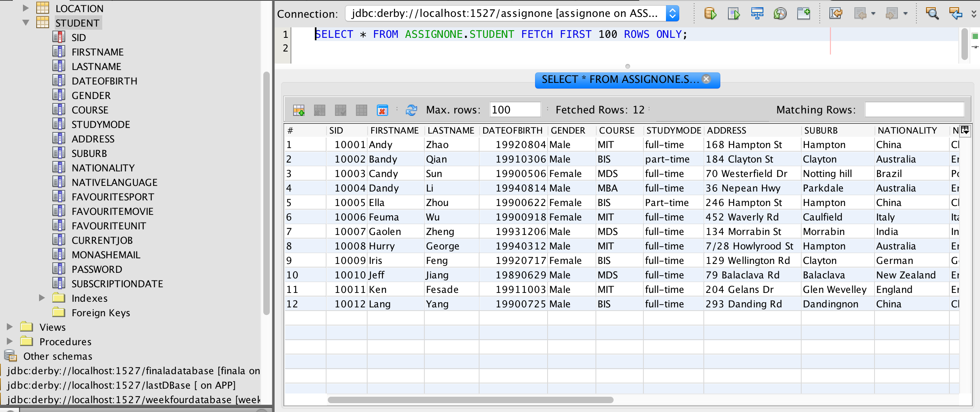

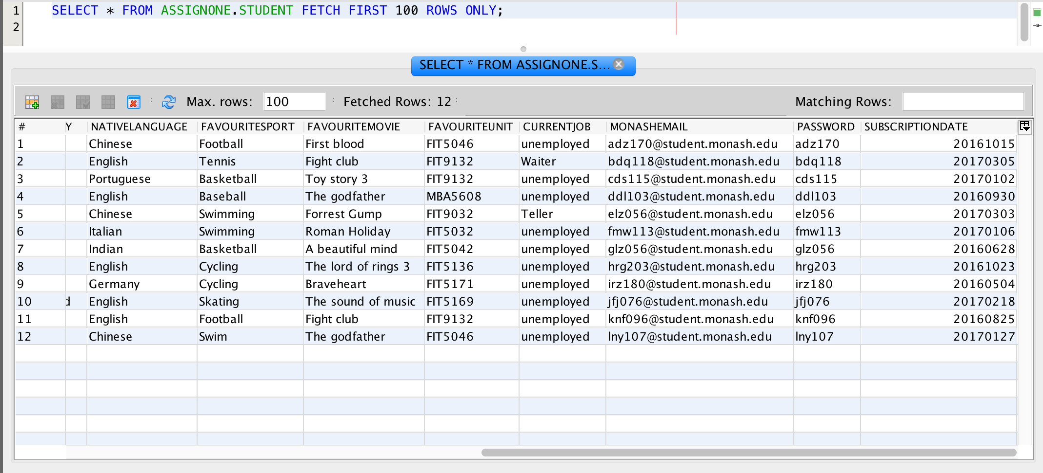

**1.2 Location Table**

1.2.1. Code for creating the table

CREATE TABLE LOCATION (LOCATIONID INTEGER NOT NULL, LATITUDE DOUBLE, LONGITUDE DOUBLE, LOCATIONNAME VARCHAR(40), SID INTEGER, DATETIME DOUBLE, PRIMARY KEY (LOCATIONID));

1.2.2. Code for inserting data to table

INSERT INTO ASSIGNONE.LOCATION (LOCATIONID, LATITUDE, LONGITUDE, LOCATIONNAME, SID, DATETIME)

VALUES (20007, -37.913083, 145.132816, 'Clayton Campus', 10002, 2.01703201327E11);

INSERT INTO ASSIGNONE.LOCATION (LOCATIONID, LATITUDE, LONGITUDE, LOCATIONNAME, SID, DATETIME)

VALUES (20008, -37.839459, 144.991908, 'South Yarra Station', 10002, 2.01703301739E11);

INSERT INTO ASSIGNONE.LOCATION (LOCATIONID, LATITUDE, LONGITUDE, LOCATIONNAME, SID, DATETIME)

VALUES (20009, -37.803713, 144.971935, 'Melbourne Museum', 10002, 2.01703060929E11);

INSERT INTO ASSIGNONE.LOCATION (LOCATIONID, LATITUDE, LONGITUDE, LOCATIONNAME, SID, DATETIME)

VALUES (20010, -37.81854, 144.966382, 'Flinders Station', 10002, 2.01703012053E11);

INSERT INTO ASSIGNONE.LOCATION (LOCATIONID, LATITUDE, LONGITUDE, LOCATIONNAME, SID, DATETIME)

VALUES (20011, -37.9381, 145.002006, 'Hampton Station', 10002, 2.01703241138E11);

INSERT INTO ASSIGNONE.LOCATION (LOCATIONID, LATITUDE, LONGITUDE, LOCATIONNAME, SID, DATETIME)

VALUES (20012, -37.879445, 145.04064, 'Caulfield Campus', 10002, 2.01703191804E11);

INSERT INTO ASSIGNONE.LOCATION (LOCATIONID, LATITUDE, LONGITUDE, LOCATIONNAME, SID, DATETIME)

VALUES (20013, -37.902324, 145.180324, 'Frankston Station', 10002, 2.01703111507E11);

INSERT INTO ASSIGNONE.LOCATION (LOCATIONID, LATITUDE, LONGITUDE, LOCATIONNAME, SID, DATETIME)

VALUES (20001, -37.993083, 145.172816, 'Clayton Campus', 10001, 2.01702271205E11);

INSERT INTO ASSIGNONE.LOCATION (LOCATIONID, LATITUDE, LONGITUDE, LOCATIONNAME, SID, DATETIME)

VALUES (20002, -37.859459, 144.941908, 'South Yarra Station', 10002, 2.01703301209E11);

INSERT INTO ASSIGNONE.LOCATION (LOCATIONID, LATITUDE, LONGITUDE, LOCATIONNAME, SID, DATETIME)

VALUES (20003, -37.843713, 144.921935, 'Melbourne Museum', 10001, 2.01703292237E11);

INSERT INTO ASSIGNONE.LOCATION (LOCATIONID, LATITUDE, LONGITUDE, LOCATIONNAME, SID, DATETIME)

VALUES (20004, -37.87854, 144.916382, 'Flinders Station', 10001, 2.01703241828E11);

INSERT INTO ASSIGNONE.LOCATION (LOCATIONID, LATITUDE, LONGITUDE, LOCATIONNAME, SID, DATETIME)

VALUES (20005, -37.9781, 145.022006, 'Hampton Station', 10001, 2.01703271546E11);

INSERT INTO ASSIGNONE.LOCATION (LOCATIONID, LATITUDE, LONGITUDE, LOCATIONNAME, SID, DATETIME)

VALUES (20006, -37.809445, 145.07064, 'Caulfield Campus', 10001, 2.01703161804E11);

INSERT INTO ASSIGNONE.LOCATION (LOCATIONID, LATITUDE, LONGITUDE, LOCATIONNAME, SID, DATETIME)

VALUES (20014, -37.962324, 145.150324, 'Frankston Station', 10001, 2.01703141507E11);

INSERT INTO ASSIGNONE.LOCATION (LOCATIONID, LATITUDE, LONGITUDE, LOCATIONNAME, SID, DATETIME)

VALUES (20015, -37.993083, 145.172816, 'Clayton Campus', 10003, 2.01702271205E11);

INSERT INTO ASSIGNONE.LOCATION (LOCATIONID, LATITUDE, LONGITUDE, LOCATIONNAME, SID, DATETIME)

VALUES (20016, -37.874951, 145.073924, 'Glenhuntly Station', 10003, 2.01703301209E11);

INSERT INTO ASSIGNONE.LOCATION (LOCATIONID, LATITUDE, LONGITUDE, LOCATIONNAME, SID, DATETIME)

VALUES (20017, -37.813713, 144.931935, 'Melbourne Museum', 10003, 2.01703292237E11);

INSERT INTO ASSIGNONE.LOCATION (LOCATIONID, LATITUDE, LONGITUDE, LOCATIONNAME, SID, DATETIME)

VALUES (20018, -37.849405, 145.14064, 'Caulfield Campus', 10003, 2.01703241828E11);

INSERT INTO ASSIGNONE.LOCATION (LOCATIONID, LATITUDE, LONGITUDE, LOCATIONNAME, SID, DATETIME)

VALUES (20019, -37.9681, 145.032006, 'Hampton Station', 10003, 2.01703271546E11);

INSERT INTO ASSIGNONE.LOCATION (LOCATIONID, LATITUDE, LONGITUDE, LOCATIONNAME, SID, DATETIME)

VALUES (20020, -37.809445, 145.07064, 'Caulfield Campus', 10003, 2.01703161804E11);

INSERT INTO ASSIGNONE.LOCATION (LOCATIONID, LATITUDE, LONGITUDE, LOCATIONNAME, SID, DATETIME)

VALUES (20021, -37.842459, 144.971908, 'South Yarra Station', 10003, 2.01703141507E11);

INSERT INTO ASSIGNONE.LOCATION (LOCATIONID, LATITUDE, LONGITUDE, LOCATIONNAME, SID, DATETIME)

VALUES (20022, -37.933063, 145.151281, 'Clayton Campus', 10004, 2.01703152035E11);

INSERT INTO ASSIGNONE.LOCATION (LOCATIONID, LATITUDE, LONGITUDE, LOCATIONNAME, SID, DATETIME)

VALUES (20023, -37.830459, 144.901908, 'South Yarra Station', 10002, 2.01703281422E11);

INSERT INTO ASSIGNONE.LOCATION (LOCATIONID, LATITUDE, LONGITUDE, LOCATIONNAME, SID, DATETIME)

VALUES (20024, -37.833723, 144.951915, 'Melbourne Museum', 10004, 2.01703151927E11);

INSERT INTO ASSIGNONE.LOCATION (LOCATIONID, LATITUDE, LONGITUDE, LOCATIONNAME, SID, DATETIME)

VALUES (20025, -37.81054, 144.976382, 'Flinders Station', 10004, 2.01702281139E11);

INSERT INTO ASSIGNONE.LOCATION (LOCATIONID, LATITUDE, LONGITUDE, LOCATIONNAME, SID, DATETIME)

VALUES (20026, -37.9421, 145.042056, 'Hampton Station', 10004, 2.01703270955E11);

INSERT INTO ASSIGNONE.LOCATION (LOCATIONID, LATITUDE, LONGITUDE, LOCATIONNAME, SID, DATETIME)

VALUES (20027, -37.892445, 145.06064, 'Caulfield Campus', 10004, 2.01703191504E11);

INSERT INTO ASSIGNONE.LOCATION (LOCATIONID, LATITUDE, LONGITUDE, LOCATIONNAME, SID, DATETIME)

VALUES (20028, -37.909324, 145.186324, 'Frankston Station', 10004, 2.01703241557E11);

INSERT INTO ASSIGNONE.LOCATION (LOCATIONID, LATITUDE, LONGITUDE, LOCATIONNAME, SID, DATETIME)

VALUES (20029, -37.920003, 145.130816, 'Clayton Campus', 10005, 2.01702271234E11);

INSERT INTO ASSIGNONE.LOCATION (LOCATIONID, LATITUDE, LONGITUDE, LOCATIONNAME, SID, DATETIME)

VALUES (20030, -37.837429, 144.989901, 'South Yarra Station', 10002, 2.01703261535E11);

INSERT INTO ASSIGNONE.LOCATION (LOCATIONID, LATITUDE, LONGITUDE, LOCATIONNAME, SID, DATETIME)

VALUES (20031, -37.801613, 144.969931, 'Melbourne Museum', 10005, 2.01703301348E11);

INSERT INTO ASSIGNONE.LOCATION (LOCATIONID, LATITUDE, LONGITUDE, LOCATIONNAME, SID, DATETIME)

VALUES (20032, -37.82134, 144.959381, 'Flinders Station', 10005, 2.01703192203E11);

INSERT INTO ASSIGNONE.LOCATION (LOCATIONID, LATITUDE, LONGITUDE, LOCATIONNAME, SID, DATETIME)

VALUES (20033, -37.94217, 145.009106, 'Hampton Station', 10005, 2.01703290927E11);

INSERT INTO ASSIGNONE.LOCATION (LOCATIONID, LATITUDE, LONGITUDE, LOCATIONNAME, SID, DATETIME)

VALUES (20034, -37.88044, 145.0106, 'Caulfield Campus', 10005, 2.01703221151E11);

INSERT INTO ASSIGNONE.LOCATION (LOCATIONID, LATITUDE, LONGITUDE, LOCATIONNAME, SID, DATETIME)

VALUES (20035, -37.900324, 145.184324, 'Frankston Station', 10005, 2.01703221544E11);

INSERT INTO ASSIGNONE.LOCATION (LOCATIONID, LATITUDE, LONGITUDE, LOCATIONNAME, SID, DATETIME)

VALUES (20036, -37.913083, 145.132816, 'Clayton Campus', 10006, 2.01703231525E11);

INSERT INTO ASSIGNONE.LOCATION (LOCATIONID, LATITUDE, LONGITUDE, LOCATIONNAME, SID, DATETIME)

VALUES (20037, -37.839459, 144.991908, 'South Yarra Station', 10006, 2.01703271749E11);

INSERT INTO ASSIGNONE.LOCATION (LOCATIONID, LATITUDE, LONGITUDE, LOCATIONNAME, SID, DATETIME)

VALUES (20038, -37.803713, 144.971935, 'Melbourne Museum', 10006, 2.01703101533E11);

INSERT INTO ASSIGNONE.LOCATION (LOCATIONID, LATITUDE, LONGITUDE, LOCATIONNAME, SID, DATETIME)

VALUES (20039, -37.81854, 144.966382, 'Flinders Station', 10006, 2.01702181839E11);

INSERT INTO ASSIGNONE.LOCATION (LOCATIONID, LATITUDE, LONGITUDE, LOCATIONNAME, SID, DATETIME)

VALUES (20040, -37.9381, 145.002006, 'Hampton Station', 10006, 2.01703301538E11);

INSERT INTO ASSIGNONE.LOCATION (LOCATIONID, LATITUDE, LONGITUDE, LOCATIONNAME, SID, DATETIME)

VALUES (20041, -37.879445, 145.04064, 'Caulfield Campus', 10006, 2.01703271843E11);

INSERT INTO ASSIGNONE.LOCATION (LOCATIONID, LATITUDE, LONGITUDE, LOCATIONNAME, SID, DATETIME)

VALUES (20042, -37.902324, 145.180324, 'Frankston Station', 10006, 2.01703291557E11);

INSERT INTO ASSIGNONE.LOCATION (LOCATIONID, LATITUDE, LONGITUDE, LOCATIONNAME, SID, DATETIME)

VALUES (20043, -37.840459, 144.991908, 'South Yarra Station', 10007, 2.01703290914E11);

INSERT INTO ASSIGNONE.LOCATION (LOCATIONID, LATITUDE, LONGITUDE, LOCATIONNAME, SID, DATETIME)

VALUES (20044, -37.802971, 144.971935, 'Melbourne Museum', 10007, 2.01703301524E11);

INSERT INTO ASSIGNONE.LOCATION (LOCATIONID, LATITUDE, LONGITUDE, LOCATIONNAME, SID, DATETIME)

VALUES (20045, -37.90192, 145.179832, 'Frankston Station', 10007, 2.01703172248E11);

INSERT INTO ASSIGNONE.LOCATION (LOCATIONID, LATITUDE, LONGITUDE, LOCATIONNAME, SID, DATETIME)

VALUES (20046, -37.8794, 145.0405, 'Caulfield Campus', 10008, 2.01703011804E11);

INSERT INTO ASSIGNONE.LOCATION (LOCATIONID, LATITUDE, LONGITUDE, LOCATIONNAME, SID, DATETIME)

VALUES (20047, -37.914, 145.132, 'Clayton Campus', 10009, 2.01703301327E11);

INSERT INTO ASSIGNONE.LOCATION (LOCATIONID, LATITUDE, LONGITUDE, LOCATIONNAME, SID, DATETIME)

VALUES (20048, -37.813, 144.965, 'Flinders Station', 10009, 2.01703019053E11);

INSERT INTO ASSIGNONE.LOCATION (LOCATIONID, LATITUDE, LONGITUDE, LOCATIONNAME, SID, DATETIME)

VALUES (20049, -37.8764, 145.04, 'Caulfield Campus', 10009, 2.01703121804E11);

INSERT INTO ASSIGNONE.LOCATION (LOCATIONID, LATITUDE, LONGITUDE, LOCATIONNAME, SID, DATETIME)

VALUES (20050, -37.81854, 144.966382, 'Flinders Station', 10010, 2017.0);

INSERT INTO ASSIGNONE.LOCATION (LOCATIONID, LATITUDE, LONGITUDE, LOCATIONNAME, SID, DATETIME)

VALUES (20051, -37.88, 145.041, 'Caulfield Campus', 10010, 2.01703291804E11);

INSERT INTO ASSIGNONE.LOCATION (LOCATIONID, LATITUDE, LONGITUDE, LOCATIONNAME, SID, DATETIME)

VALUES (20052, -37.884, 145.044, 'Clayton Campus', 10011, 2.0170302E18);

INSERT INTO ASSIGNONE.LOCATION (LOCATIONID, LATITUDE, LONGITUDE, LOCATIONNAME, SID, DATETIME)

VALUES (20053, -37.886, 145.045, 'Clayton Station', 10011, 2.0170318E18);

INSERT INTO ASSIGNONE.LOCATION (LOCATIONID, LATITUDE, LONGITUDE, LOCATIONNAME, SID, DATETIME)

VALUES (20054, -37.888, 145.047, 'Caulfield Campus', 10011, 2.0170201E18);

INSERT INTO ASSIGNONE.LOCATION (LOCATIONID, LATITUDE, LONGITUDE, LOCATIONNAME, SID, DATETIME)

VALUES (20055, -37.882, 145.046, 'Caulfield Campus', 10011, 2.0170324E18);

INSERT INTO ASSIGNONE.LOCATION (LOCATIONID, LATITUDE, LONGITUDE, LOCATIONNAME, SID, DATETIME)

VALUES (20056, -37.87, 145.041, 'Clayton Campus', 10011, 2.20170106E19);

INSERT INTO ASSIGNONE.LOCATION (LOCATIONID, LATITUDE, LONGITUDE, LOCATIONNAME, SID, DATETIME)

VALUES (20057, -37.882, 145.043, 'Caulfield Campus', 10011, 2.0170329E7);

INSERT INTO ASSIGNONE.LOCATION (LOCATIONID, LATITUDE, LONGITUDE, LOCATIONNAME, SID, DATETIME)

VALUES (20060, -37.859459, 144.941908, 'South Yarra Station', 10012, 331.0);

INSERT INTO ASSIGNONE.LOCATION (LOCATIONID, LATITUDE, LONGITUDE, LOCATIONNAME, SID, DATETIME)

VALUES (20061, -37.843713, 144.921935, 'Melbourne Museum', 10012, 301.0);

INSERT INTO ASSIGNONE.LOCATION (LOCATIONID, LATITUDE, LONGITUDE, LOCATIONNAME, SID, DATETIME)

VALUES (20063, -37.9781, 145.022006, 'Hampton Station', 10012, 228.0);

INSERT INTO ASSIGNONE.LOCATION (LOCATIONID, LATITUDE, LONGITUDE, LOCATIONNAME, SID, DATETIME)

VALUES (20064, -37.809445, 145.07064, 'Caulfield Campus', 10012, 225.0);

INSERT INTO ASSIGNONE.LOCATION (LOCATIONID, LATITUDE, LONGITUDE, LOCATIONNAME, SID, DATETIME)

VALUES (20072, -37.859459, 144.941908, 'South Yarra Station', 10011, 331.0);

INSERT INTO ASSIGNONE.LOCATION (LOCATIONID, LATITUDE, LONGITUDE, LOCATIONNAME, SID, DATETIME)

VALUES (20071, -37.843713, 144.921935, 'Melbourne Museum', 10011, 301.0);

INSERT INTO ASSIGNONE.LOCATION (LOCATIONID, LATITUDE, LONGITUDE, LOCATIONNAME, SID, DATETIME)

VALUES (20070, -37.87854, 144.916382, 'Flinders Station', 10011, 323.0);

INSERT INTO ASSIGNONE.LOCATION (LOCATIONID, LATITUDE, LONGITUDE, LOCATIONNAME, SID, DATETIME)

VALUES (20069, -37.9781, 145.022006, 'Hampton Station', 10011, 228.0);

INSERT INTO ASSIGNONE.LOCATION (LOCATIONID, LATITUDE, LONGITUDE, LOCATIONNAME, SID, DATETIME)

VALUES (20068, -37.809445, 145.07064, 'Caulfield Campus', 10011, 225.0);

INSERT INTO ASSIGNONE.LOCATION (LOCATIONID, LATITUDE, LONGITUDE, LOCATIONNAME, SID, DATETIME)

VALUES (20066, -37.8094, 145.0706, 'Caulfield Campus', 10011, 325.0);

INSERT INTO ASSIGNONE.LOCATION (LOCATIONID, LATITUDE, LONGITUDE, LOCATIONNAME, SID, DATETIME)

VALUES (20078, -37.80545, 145.07064, 'Clayton Campus', 10011, 324.0);

1.2.3. Screen shoots of the table

Right click Location table - Select view data

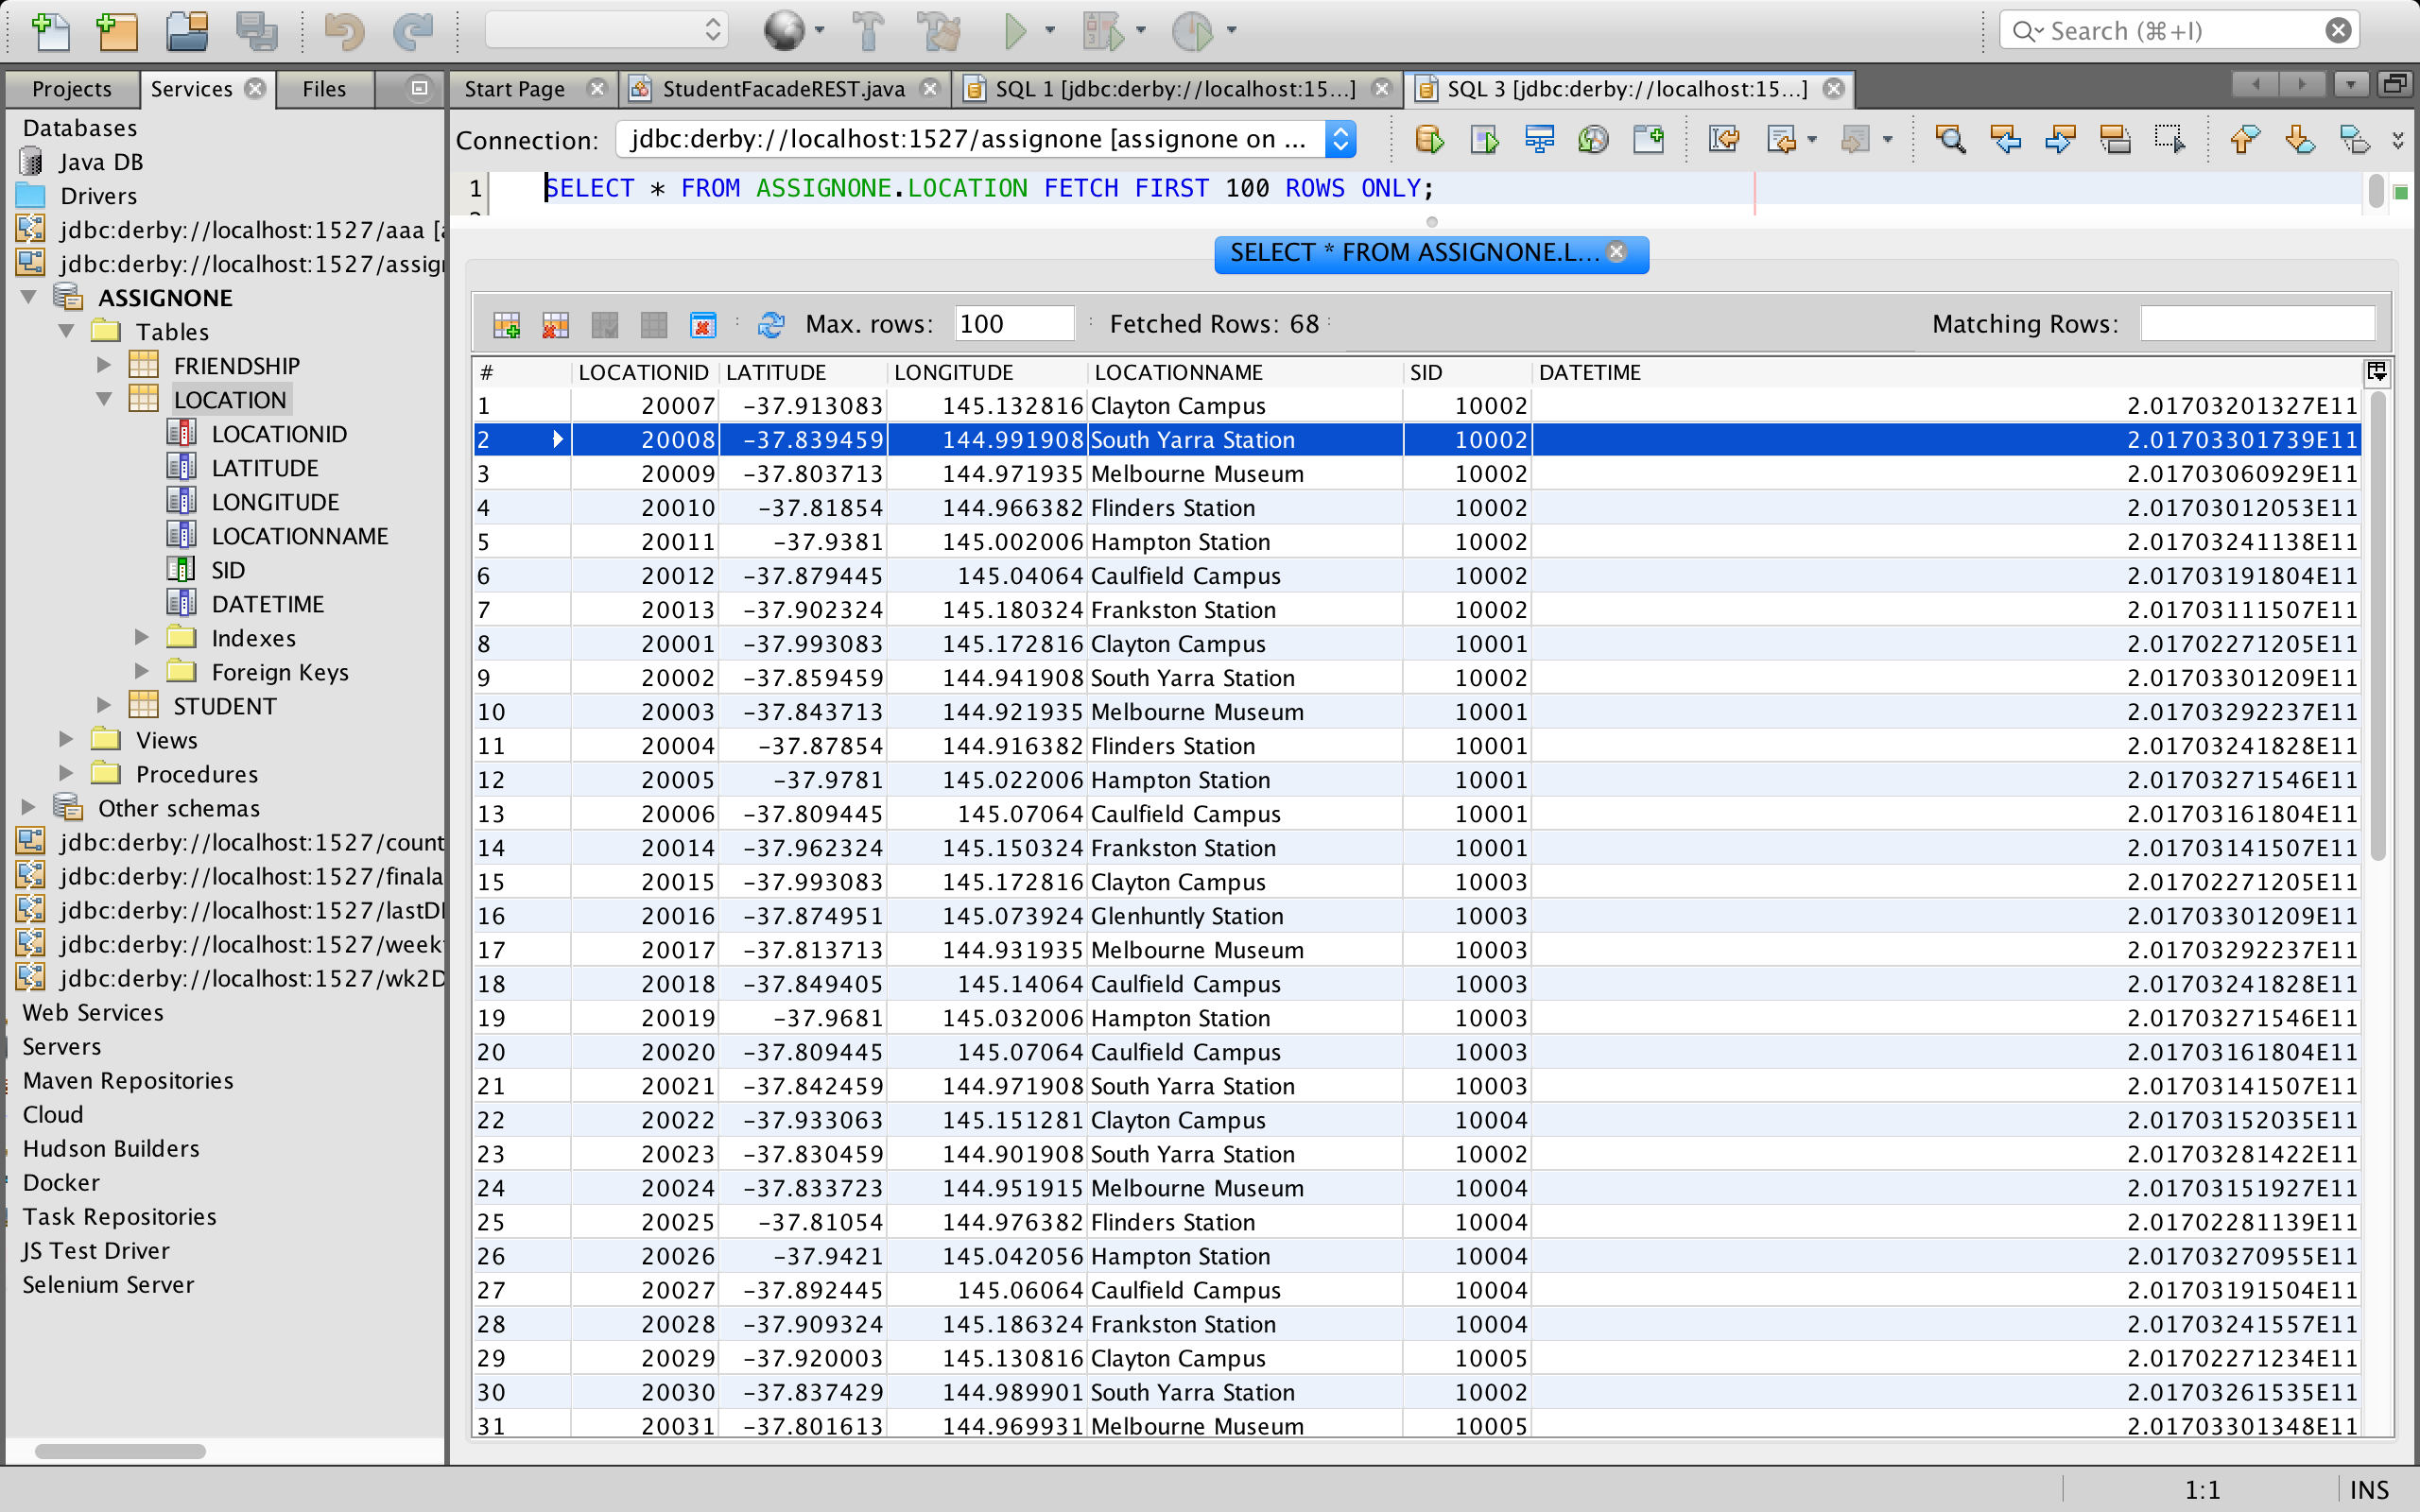

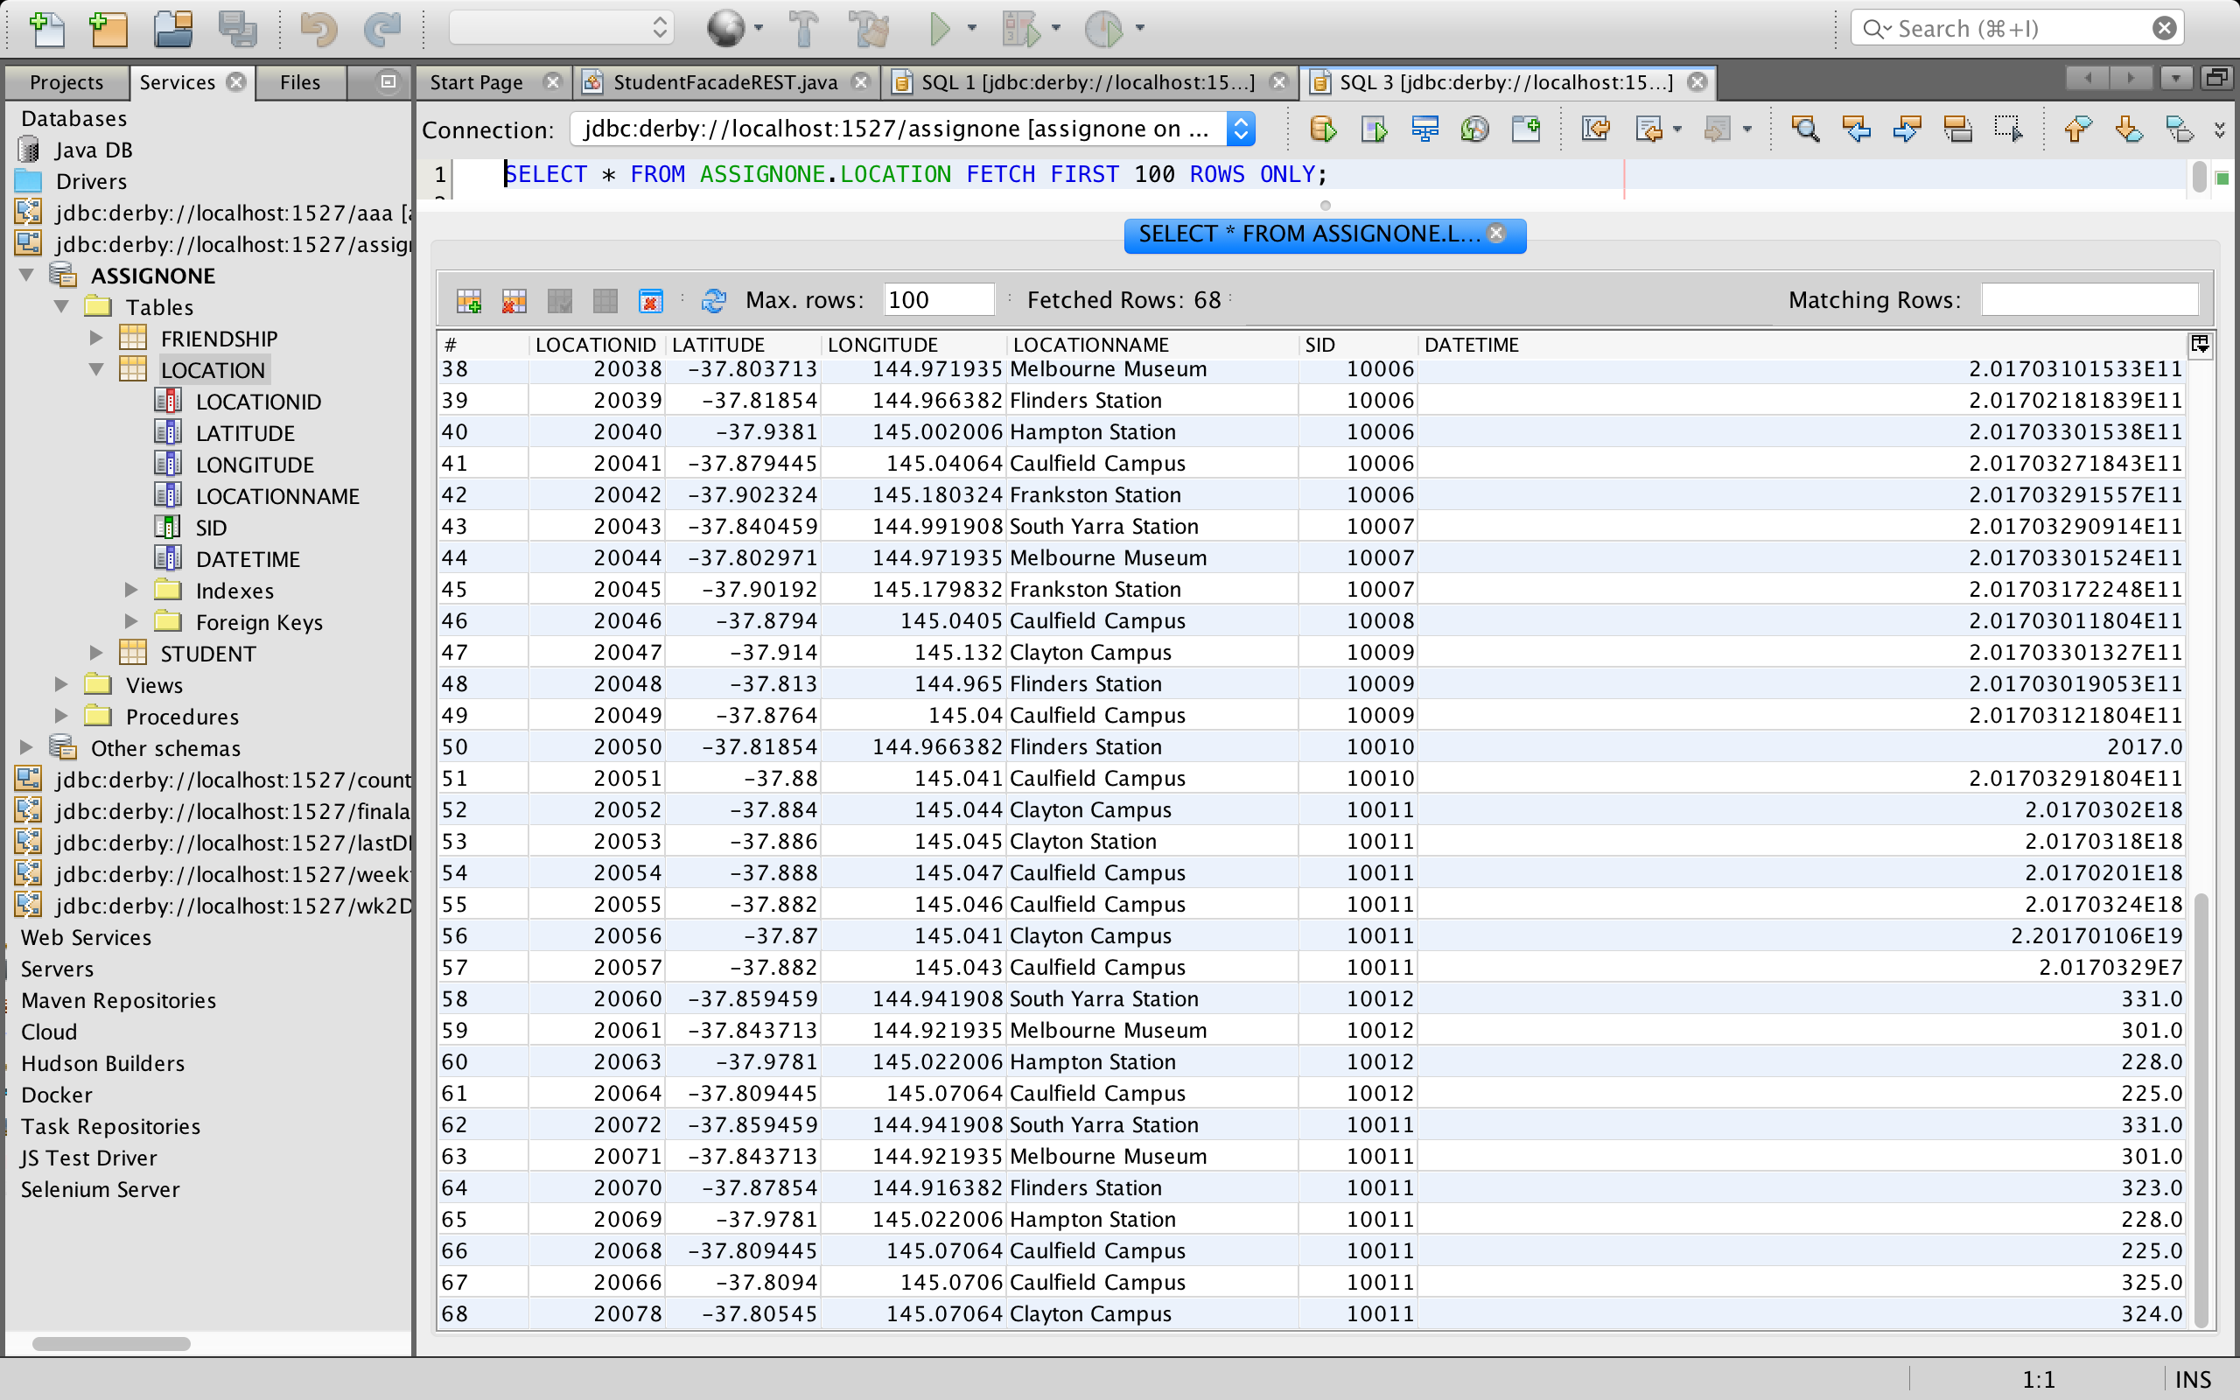

**1.3 Friendship Table**

1.3.1. Code for creating the table

CREATE TABLE FRIENDSHIP (FRIENDSHIPID INTEGER NOT NULL, STARTDATE INTEGER, ENDDATE INTEGER, FRIENDID INTEGER, SID INTEGER, PRIMARY KEY (FRIENDSHIPID));

1.3.2. Code for inserting data to table

INSERT INTO ASSIGNONE.FRIENDSHIP (FRIENDSHIPID, STARTDATE, ENDDATE, FRIENDID, SID)

VALUES (30001, 20170205, NULL, 10003, 10001);

INSERT INTO ASSIGNONE.FRIENDSHIP (FRIENDSHIPID, STARTDATE, ENDDATE, FRIENDID, SID)

VALUES (30002, 20170220, 20170320, 10005, 10001);

INSERT INTO ASSIGNONE.FRIENDSHIP (FRIENDSHIPID, STARTDATE, ENDDATE, FRIENDID, SID)

VALUES (30003, 20170301, NULL, 10008, 10001);

INSERT INTO ASSIGNONE.FRIENDSHIP (FRIENDSHIPID, STARTDATE, ENDDATE, FRIENDID, SID)

VALUES (30004, 20170220, NULL, 10010, 10001);

INSERT INTO ASSIGNONE.FRIENDSHIP (FRIENDSHIPID, STARTDATE, ENDDATE, FRIENDID, SID)

VALUES (30005, 20170329, NULL, 10007, 10002);

INSERT INTO ASSIGNONE.FRIENDSHIP (FRIENDSHIPID, STARTDATE, ENDDATE, FRIENDID, SID)

VALUES (30006, 20170324, NULL, 10007, 10003);

1.3.3. Code for preventing reverse pairs

ALTER TABLE friendship

ADD CONSTRAINT sidfriendiduniquea UNIQUE(sid, friendid);

ALTER TABLE friendship

ADD CONSTRAINT sidlessthanfriendid CHECK(sid < friendid);

1.3.4. Screen shoots of the table

Right click Friendship table - Select view data

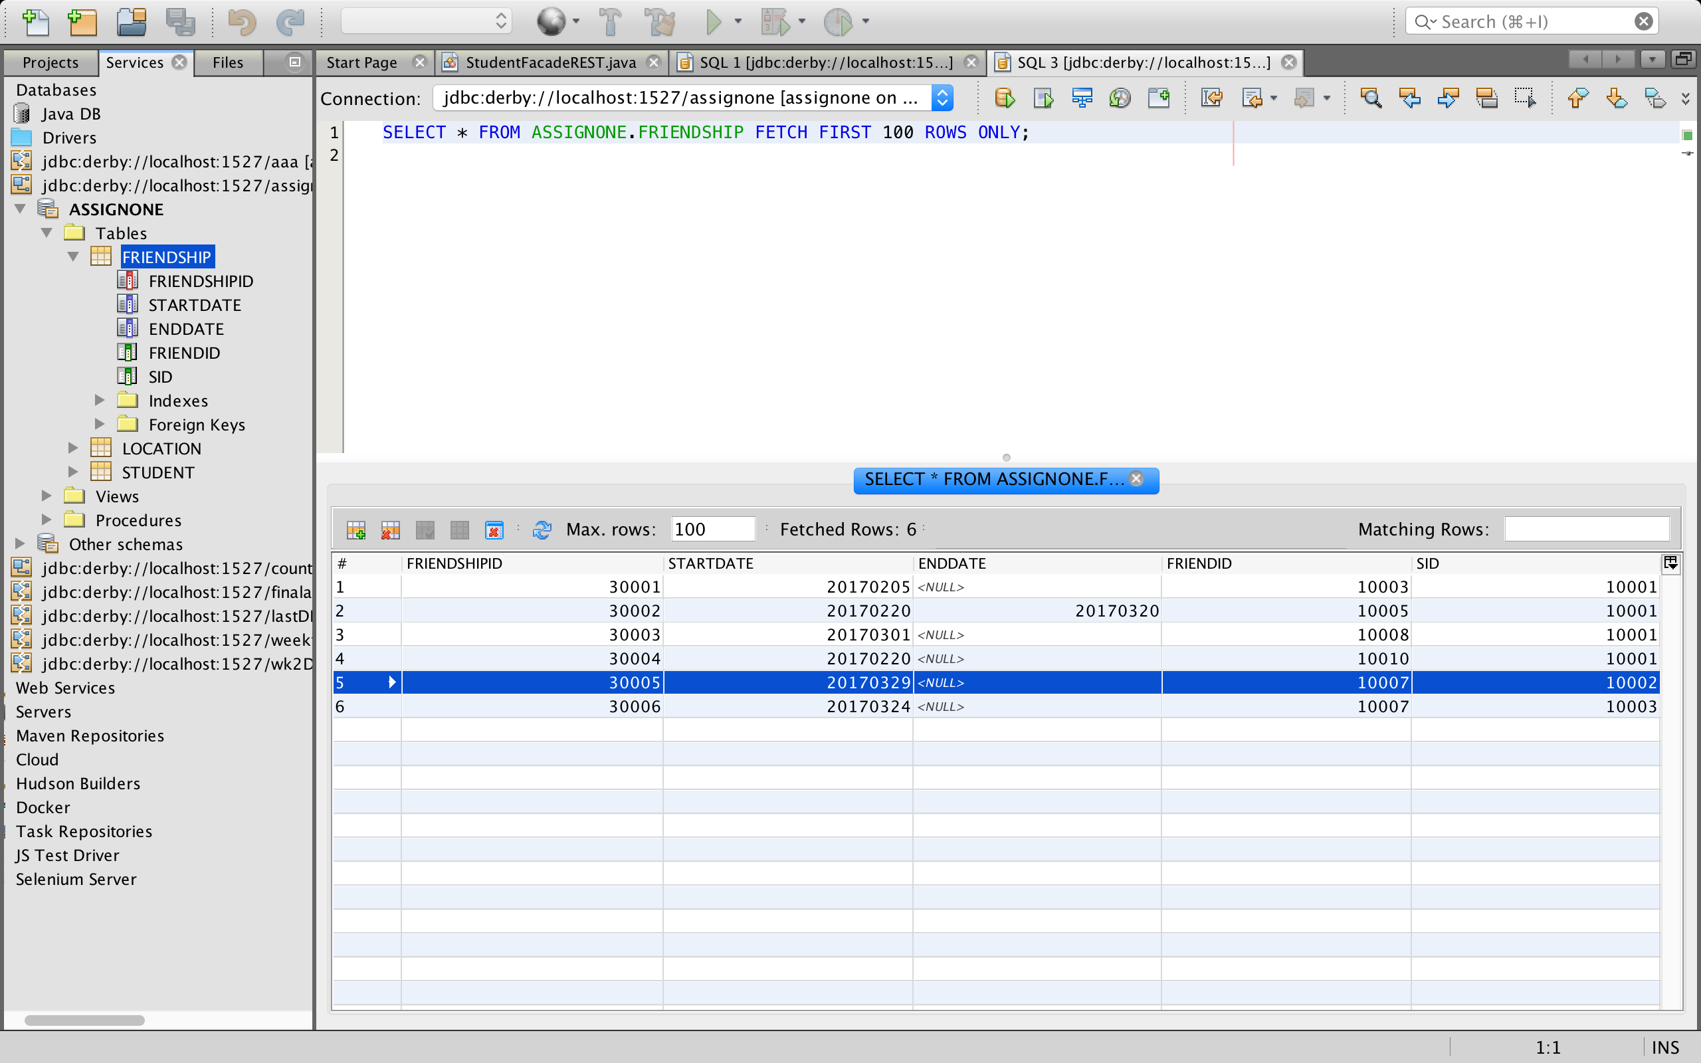

**1.4 Constraints**

1.4.1 Foreign keys

ALTER TABLE friendship

ADD FOREIGN KEY (sid) REFERENCES Student;

ALTER TABLE location

ADD FOREIGN KEY (sid) REFERENCES Student;

**Task 1 B. ER Diagram**

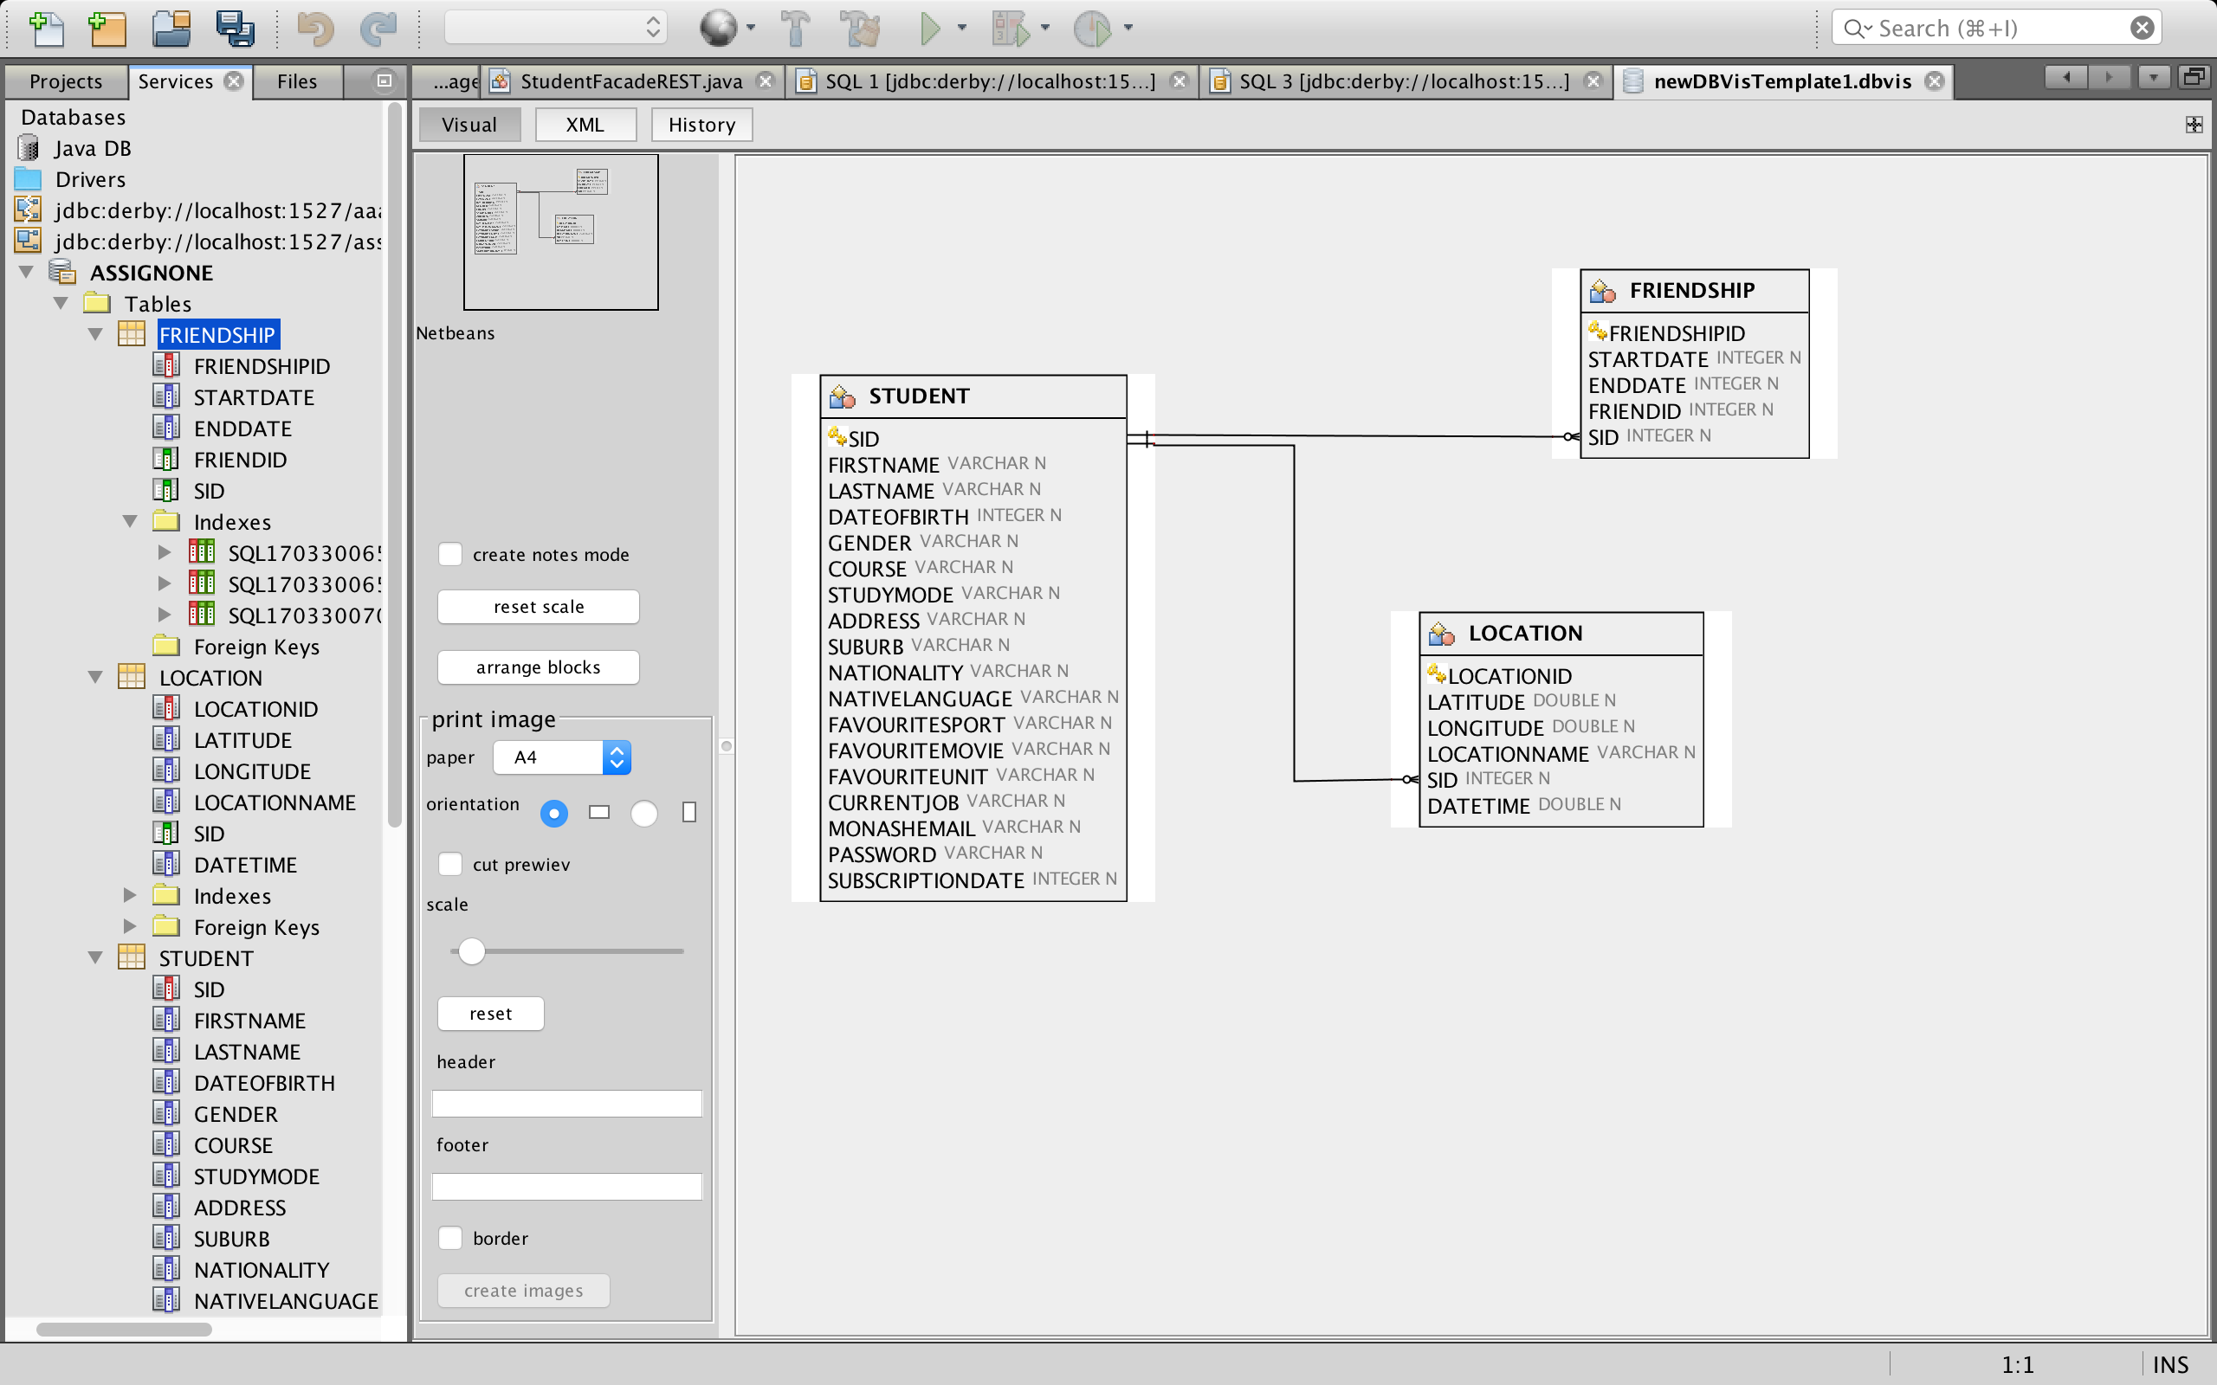

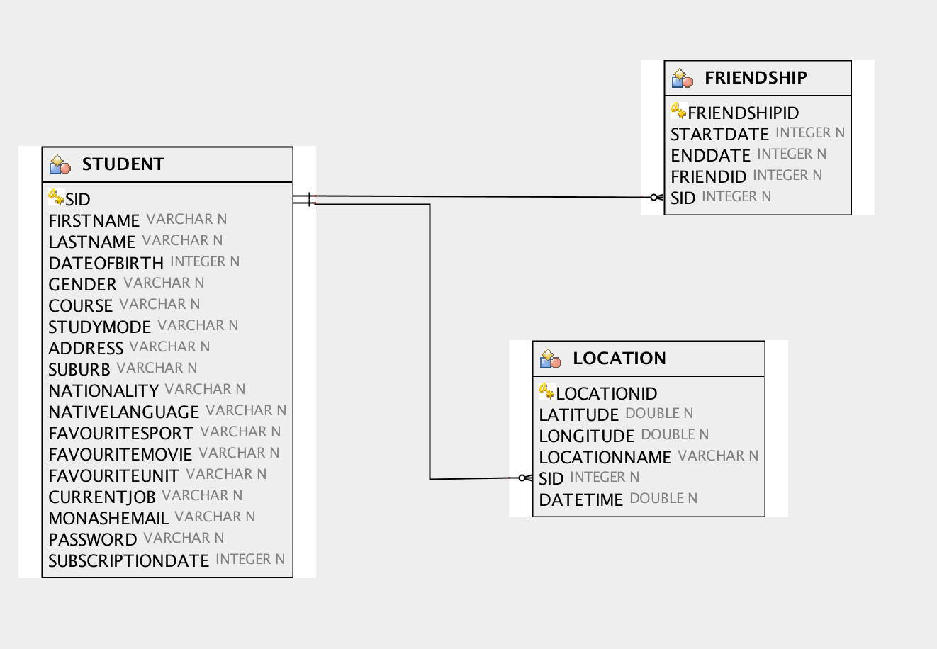

**Task 2 - RESTful Web Service**

**a) RESTful Web Service**

Create entity classes from database first, then right click the project and select Create REST web service from entity classes, the following image is a screen shoot.

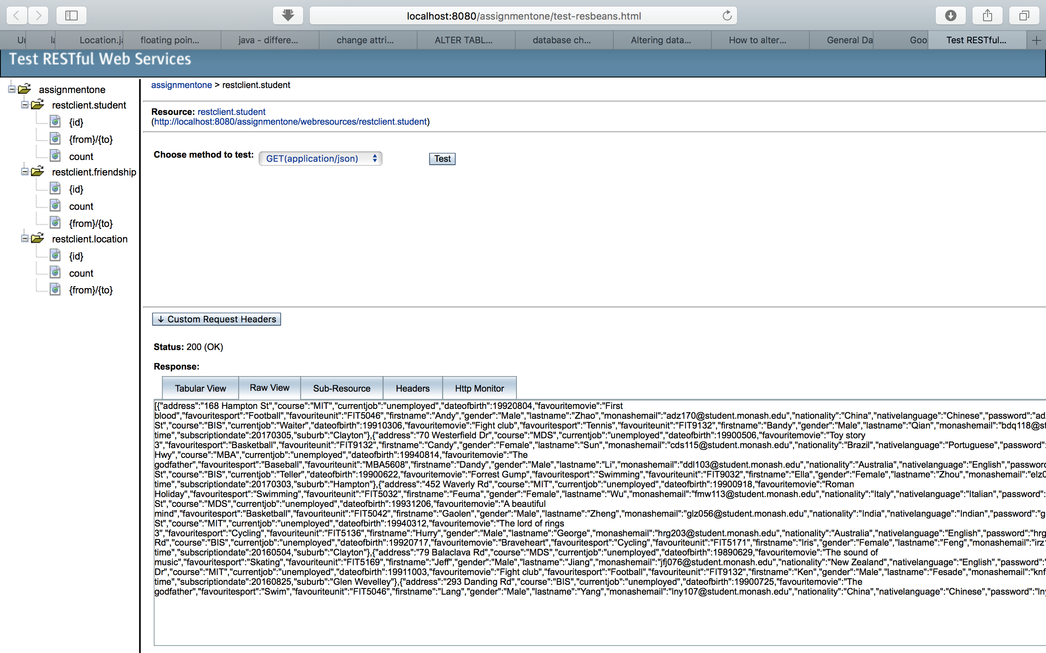

**b) RESTful Web Service – Advanced:**

**Task 2 b - 1. Additional GET methods.**

b - 1.1 Student Related code and screen shots.

The basic Queries almost already exist in three entity classes.

b - 1.1 - a. Code in StudentFacadeREST.java class.

@GET

@Path("findByFirstname/{firstname}")

@Produces({"application/json"})

public List<Student> findByFirstname(@PathParam("firstname") String firstname)

{Query query = em.createNamedQuery("Student.findByFirstname");

query.setParameter("firstname", firstname);

return query.getResultList();

}

@GET

@Path("findByLastname/{lastname}")

@Produces({"application/json"})

public List<Student> findByLastname(@PathParam("lastname") String lastname)

{Query query = em.createNamedQuery("Student.findByLastname");

query.setParameter("lastname", lastname);

return query.getResultList();

}

@GET

@Path("findByDateofbirth/{dateofbirth}")

@Produces({"application/json"})

public List<Student> findByDateofbirth(@PathParam("dateofbirth") int dateofbirth)

{Query query = em.createNamedQuery("Student.findByDateofbirth");

query.setParameter("dateofbirth", dateofbirth);

return query.getResultList();

}

@GET

@Path("findByGender/{gender}")

@Produces({"application/json"})

public List<Student> findByGender(@PathParam("gender") String gender)

{Query query = em.createNamedQuery("Student.findByGender");

query.setParameter("gender", gender);

return query.getResultList();

}

@GET

@Path("findByCourse/{course}")

@Produces({"application/json"})

public List<Student> findByCourse(@PathParam("course") String course)

{Query query = em.createNamedQuery("Student.findByCourse");

query.setParameter("course", course);

return query.getResultList();

}

@GET

@Path("findByStudymode/{studymode}")

@Produces({"application/json"})

public List<Student> findByStudymode(@PathParam("studymode") String studymode)

{Query query = em.createNamedQuery("Student.findByStudymode");

query.setParameter("studymode", studymode);

return query.getResultList();

}

@GET

@Path("findByAddress/{address}")

@Produces({"application/json"})

public List<Student> findByAddress(@PathParam("address") String address)

{Query query = em.createNamedQuery("Student.findByAddress");

query.setParameter("address", address);

return query.getResultList();

}

@GET

@Path("findBySuburb/{suburb}")

@Produces({"application/json"})

public List<Student> findBySuburb(@PathParam("suburb") String suburb)

{Query query = em.createNamedQuery("Student.findBySuburb");

query.setParameter("suburb", suburb);

return query.getResultList();

}

@GET

@Path("findByNationality/{nationality}")

@Produces({"application/json"})

public List<Student> findByNationality(@PathParam("nationality") String nationality)

{Query query = em.createNamedQuery("Student.findByNationality");

query.setParameter("nationality", nationality);

return query.getResultList();

}

@GET

@Path("findByNativelanguage/{nativelanguage}")

@Produces({"application/json"})

public List<Student> findByNativelanguage(@PathParam("nativelanguage") String nativelanguage)

{Query query = em.createNamedQuery("Student.findByNativelanguage");

query.setParameter("nativelanguage", nativelanguage);

return query.getResultList();

}

@GET

@Path("findByFavouritesport/{favouritesport}")

@Produces({"application/json"})

public List<Student> findByFavouritesport(@PathParam("favouritesport") String favouritesport)

{Query query = em.createNamedQuery("Student.findByFavouritesport");

query.setParameter("favouritesport", favouritesport);

return query.getResultList();

}

@GET

@Path("findByFavouritemovie/{favouritemovie}")

@Produces({"application/json"})

public List<Student> findByFavouritemovie(@PathParam("favouritemovie") String favouritemovie)

{Query query = em.createNamedQuery("Student.findByFavouritemovie");

query.setParameter("favouritemovie", favouritemovie);

return query.getResultList();

}

@GET

@Path("findByFavouriteunit/{favouriteunit}")

@Produces({"application/json"})

public List<Student> findByFavouriteunit(@PathParam("favouriteunit") String favouriteunit)

{Query query = em.createNamedQuery("Student.findByFavouriteunit");

query.setParameter("favouriteunit", favouriteunit);

return query.getResultList();

}

@GET

@Path("findByCurrentjob/{currentjob}")

@Produces({"application/json"})

public List<Student> findByCurrentjob(@PathParam("currentjob") String currentjob)

{Query query = em.createNamedQuery("Student.findByCurrentjob");

query.setParameter("currentjob", currentjob);

return query.getResultList();

}

@GET

@Path("findByMonashemail/{monashemail}")

@Produces({"application/json"})

public List<Student> findByMonashemail(@PathParam("monashemail") String monashemail)

{Query query = em.createNamedQuery("Student.findByMonashemail");

query.setParameter("monashemail", monashemail);

return query.getResultList();

}

@GET

@Path("findByPassword/{password}")

@Produces({"application/json"})

public List<Student> findByPassword(@PathParam("password") String password)

{Query query = em.createNamedQuery("Student.findByPassword");

query.setParameter("password", password);

return query.getResultList();

}

@GET

@Path("findBySubscriptiondate/{subscriptiondate}")

@Produces({"application/json"})

public List<Student> findBySubscriptiondate(@PathParam("subscriptiondate") int subscriptiondate)

{Query query = em.createNamedQuery("Student.findBySfindBySubscriptiondate");

query.setParameter("subscriptiondate", subscriptiondate);

return query.getResultList();

}

b - 1.1 - b. Screen shots for testing REST web services for student.

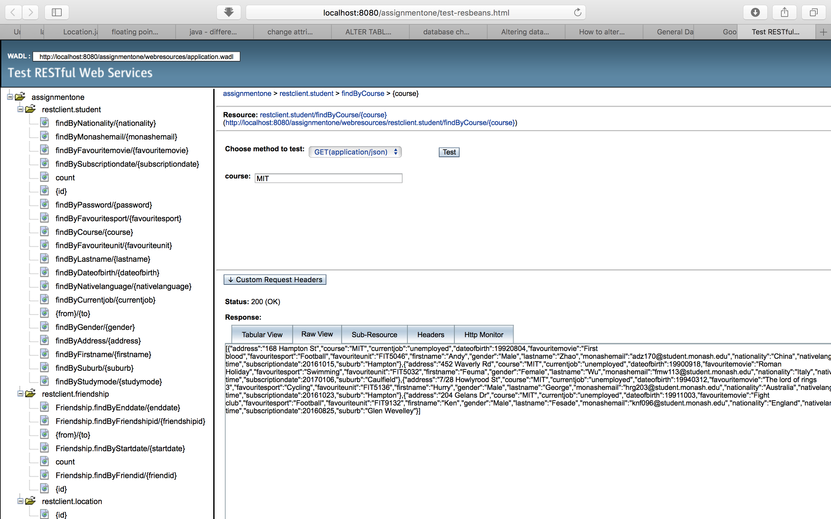

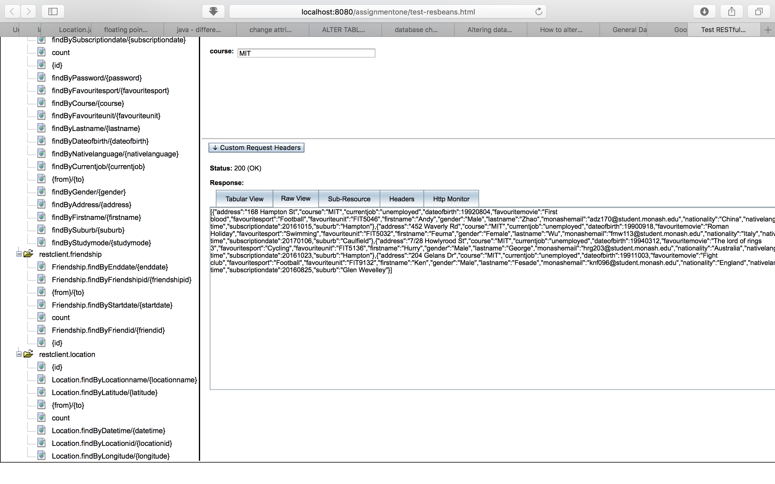

**Task 2 B - 1.2 Location Related code and screen shots.**

The basic Queries almost already exist in three entity classes.

b - 1.2 - a. Code in Location FacadeREST.java class.

@GET

@Path("Location.findByLocationid/{locationid}")

@Produces({"application/json"})

public List<Location> findByLocationid(@PathParam("locationid") int locationid)

{Query query = em.createNamedQuery("Location.findByLocationid");

query.setParameter("locationid", locationid);

return query.getResultList();

}

@GET

@Path("Location.findByLongitude/{longitude}")

@Produces({"application/json"})

public List<Location> findByLongitude(@PathParam("longitude") double longitude)

{Query query = em.createNamedQuery("Location.findByLongitude");

query.setParameter("longitude", longitude);

return query.getResultList();

}

@GET

@Path("Location.findByLatitude/{latitude}")

@Produces({"application/json"})

public List<Location> findByLatitude(@PathParam("latitude") double latitude)

{Query query = em.createNamedQuery("Location.findByLatitude");

query.setParameter("latitude", latitude);

return query.getResultList();

}

@GET

@Path("Location.findByLocationname/{locationname}")

@Produces({"application/json"})

public List<Location> findByLocationname(@PathParam("locationname") String locationname)

{Query query = em.createNamedQuery("Location.findByLocationname");

query.setParameter("locationname", locationname);

return query.getResultList();

}

@GET

@Path("Location.findByDatetime/{datetime}")

@Produces({"application/json"})

public List<Location> findByDatetime(@PathParam("datetime") double datetime)

{Query query = em.createNamedQuery("Location.findByDatetime");

query.setParameter("datetime", datetime);

return query.getResultList();

}

b - 1.2 - b. Screen shots for testing REST web services for location.

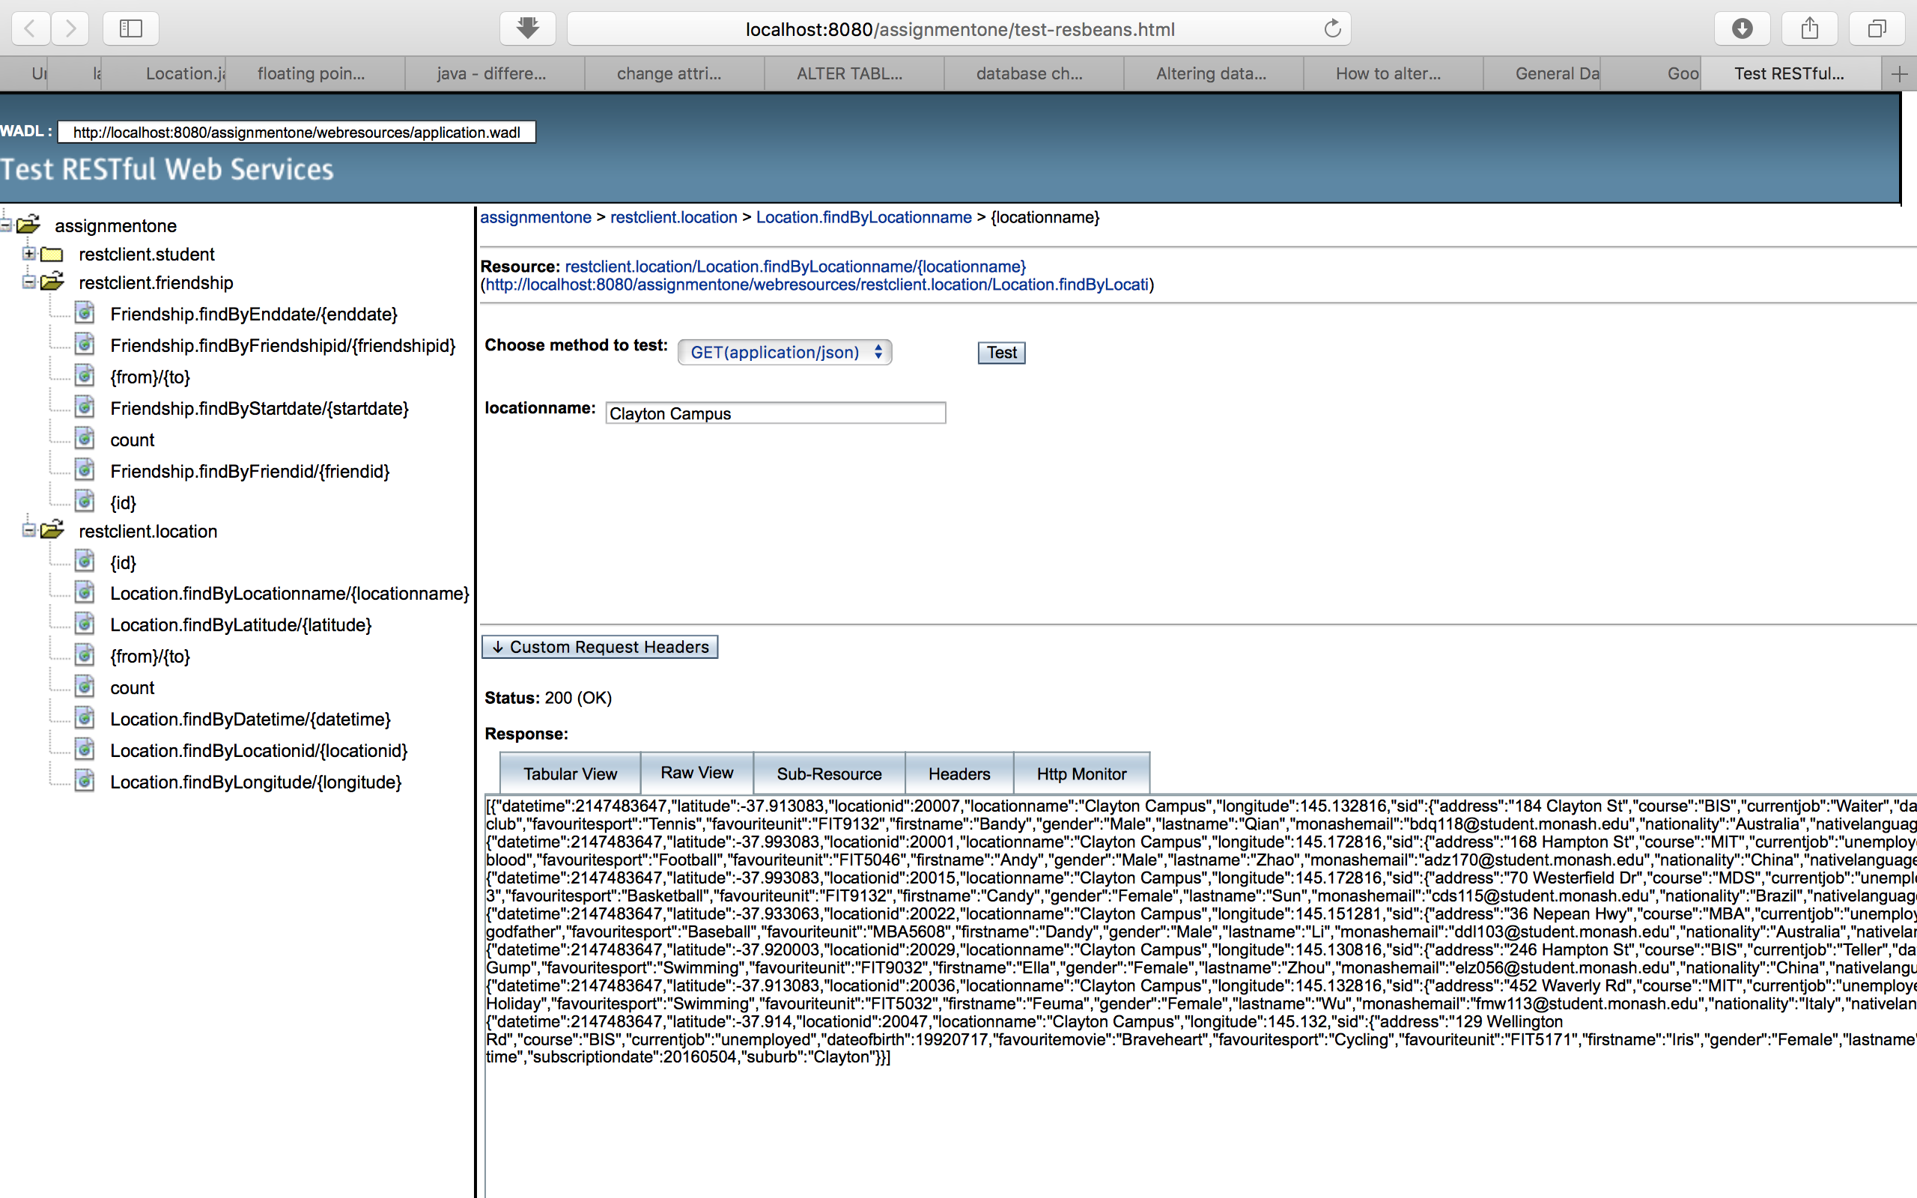

b - 1.3 Friendship Related code and screen shots.

The basic Queries almost already exist in three entity classes.

b - 1.3 - a. Code in friendshipFacadeREST.java class.

@GET

@Path("Friendship.findByFriendshipid/{friendshipid}")

@Produces({"application/json"})

public List<Friendship> findByFriendshipid(@PathParam("friendshipid") int friendshipid)

{Query query = em.createNamedQuery("Friendship.findByFriendshipid");

query.setParameter("friendshipid", friendshipid);

return query.getResultList();

}

@GET

@Path("Friendship.findByStartdate/{startdate}")

@Produces({"application/json"})

public List<Friendship> findByStartdated(@PathParam("startdate") int startdate)

{Query query = em.createNamedQuery("Friendship.findByStartdate");

query.setParameter("startdate", startdate);

return query.getResultList();

}

@GET

@Path("Friendship.findByEnddate/{enddate}")

@Produces({"application/json"})

public List<Friendship> findByEnddate(@PathParam("enddate") int enddate)

{Query query = em.createNamedQuery("Friendship.findByEnddate");

query.setParameter("enddate", enddate);

return query.getResultList();

}

@GET

@Path("Friendship.findByFriendid/{friendid}")

@Produces({"application/json"})

public List<Friendship> findByFriendid(@PathParam("friendid") int friendid)

{Query query = em.createNamedQuery("Friendship.findByFriendid");

query.setParameter("friendid", friendid);

return query.getResultList();

}

b - 1.3 - b. Screen shots for testing REST web services for friendship.

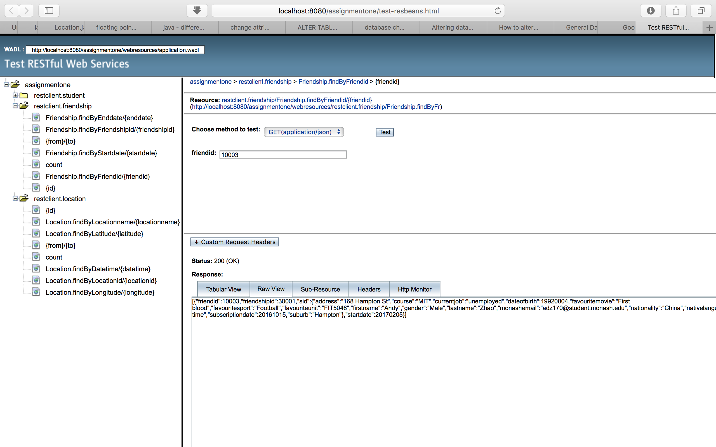

**Task 2 B - (2) Dynamic Query**

Task 2b - (2) - a. Code in StudentFacade.REST. java class

// Task 2 - b - (2)

@GET

@Path("findByCourseANDgender/{course}/{gender}")

@Produces({"application/json"})

public List<Student> findByCourseANDgender(@PathParam("course") String course, @PathParam("gender") String gender)

{

TypedQuery<Student> q = em.createQuery ("SELECT s FROM Student s WHERE s.course = :course AND s.gender = :gender", Student.class);

q.setParameter("course", course);

q.setParameter("gender", gender);

return q.getResultList();

}

Task 2b - (2) - b. Screen shot

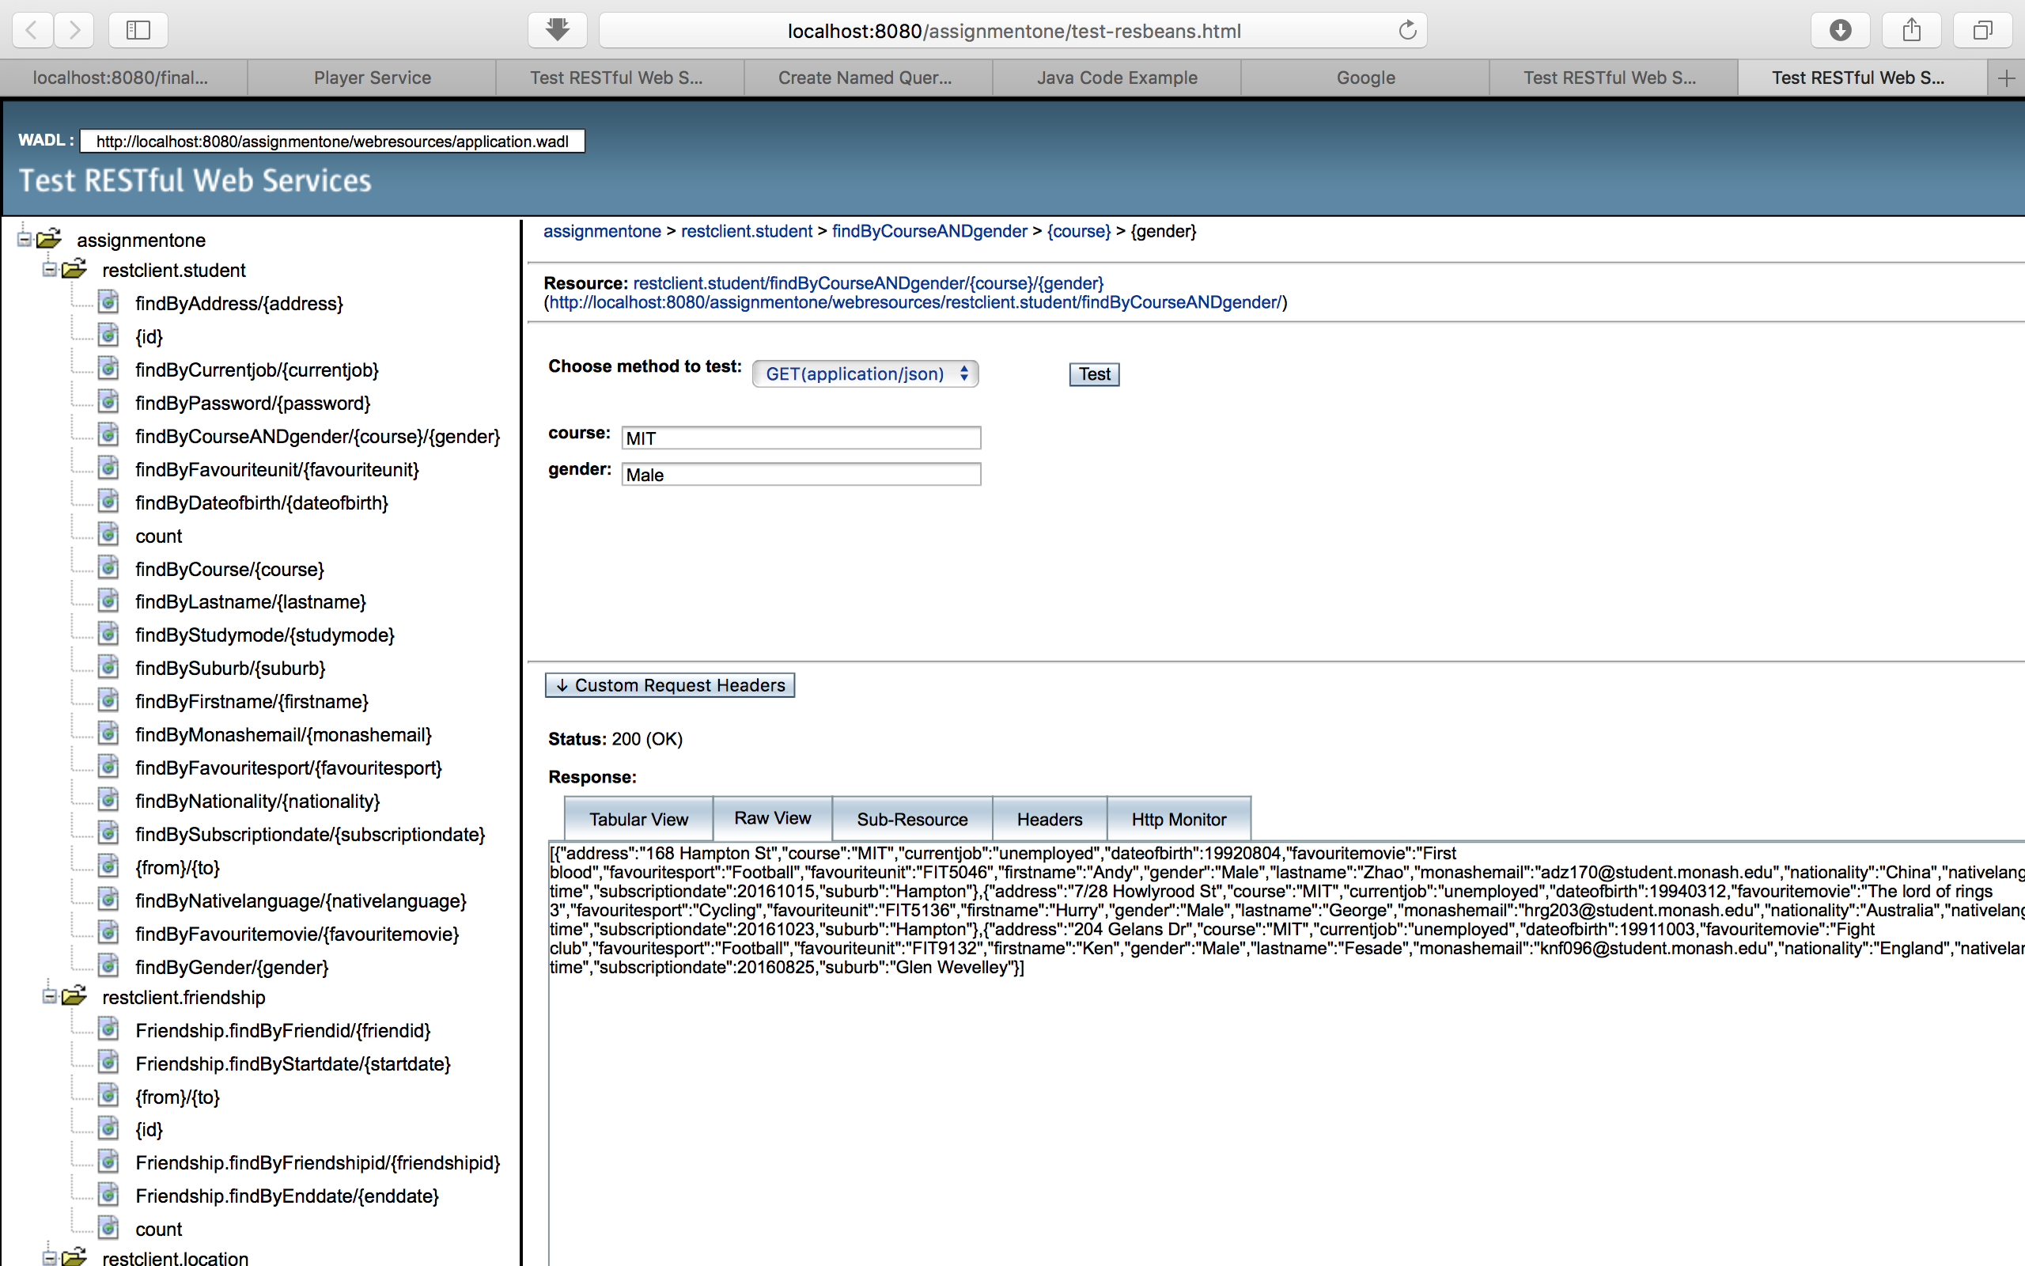

**Task 2 B - (3) Implicit join and Dynamic query**

Task 2b - (3) - a. Code in LocationFacadeREST.java class.

@GET

@Path("findByCourseANDlocationName/{course}/{locationname}")

@Produces({"application/json"})

public List<Location> findByCourseANDlocationName(@PathParam("course") String course, @PathParam("locationname") String locationname)

{

TypedQuery<Location> q = em.createQuery("SELECT l FROM Location l WHERE l.sid.course = :course AND l.locationname = :locationname", Location.class);

q.setParameter("course", course);

q.setParameter("locationname", locationname);

return q.getResultList();

}

Task 2b - (3) – b. Screen shot

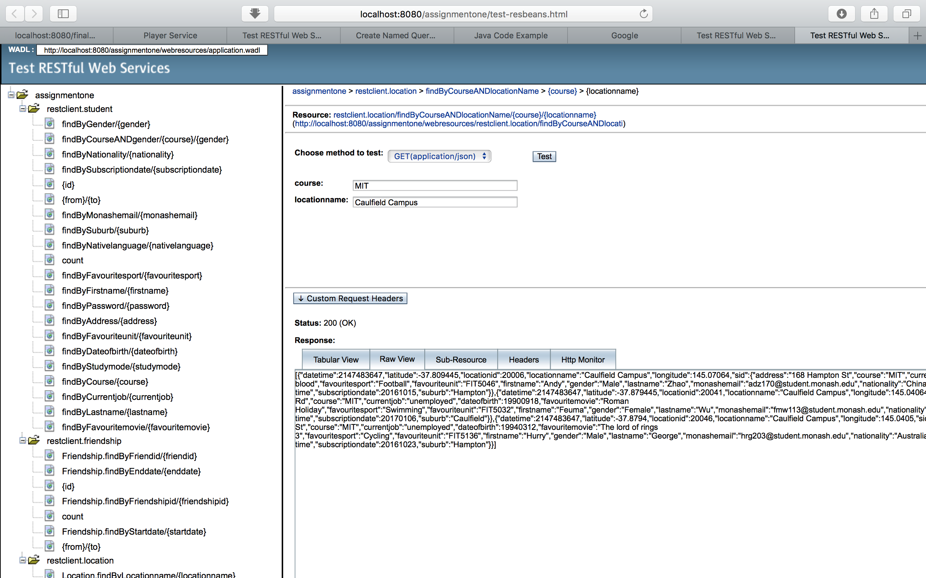

**Task 2 B - (4) Explicit join and Static query**

Task 2b - (4) – a. Code in StudentFacadeREST class

@GET

@Path("findByCourseANDfriendid/{course}/{friendid}")

@Produces({"application/json"})

public List<Student> findByCourseANDfriendid(@PathParam("course") String course, @PathParam("friendid") int friendid)

{

Query query = em.createNamedQuery("Student.findByCourseANDfriendid");

query.setParameter("course", course);

query.setParameter("friendid", friendid);

return query.getResultList();

}

Task 2b - (4) – b. Code in Student.java class

@NamedQuery(name = "Student.findByCourseANDfriendid", query = "SELECT s FROM Student s JOIN s.friendshipCollection f WHERE f.friendid = :friendid AND s.course = :course")

Task 2b - (4) – c. Screen shot

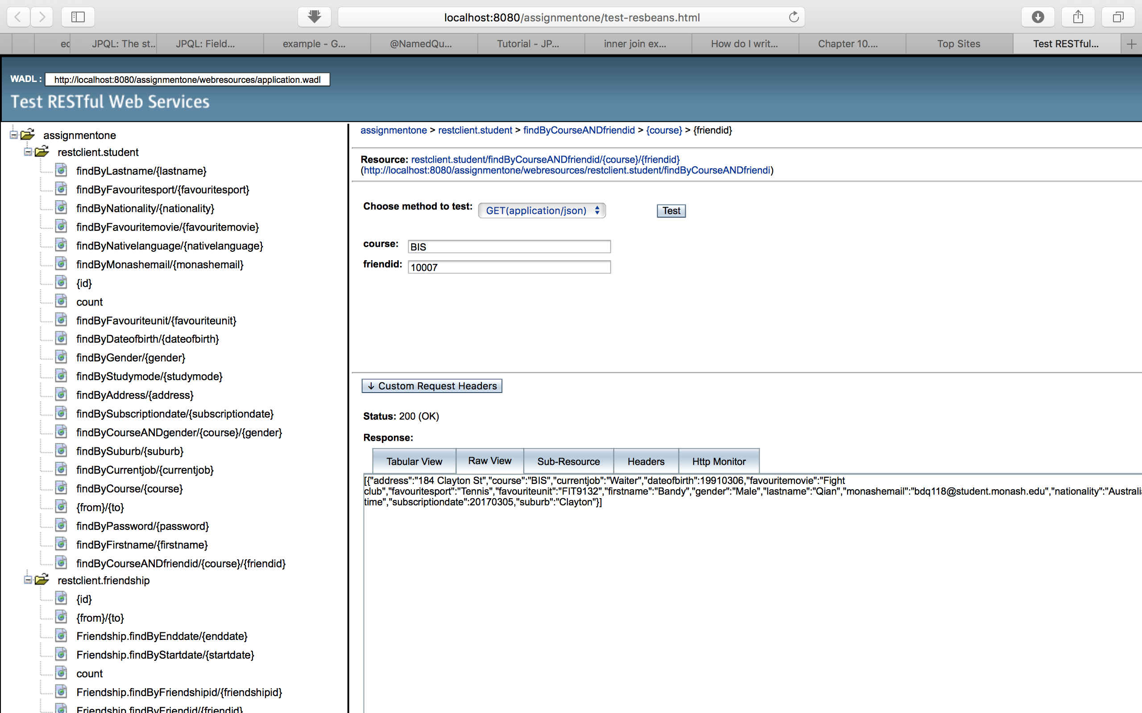

**Task 3 - REST methods for generating reports**

**Task 3a**

**Task 3a - (1). Code in LocationFacadeREST class**

@GET

@Path("findBySidWithDates/{sid}/{sdate}/{edate}")

@Produces({"application/json"})

public JsonObject findBySidWithDates(@PathParam("sid") int sid, @PathParam("sdate") double sdate, @PathParam("edate") double edate)

{

TypedQuery<Object[]> q = em.createQuery("SELECT l.locationname, count(l.locationname) FROM Location l WHERE l.sid.sid = :sid AND l.datetime >= :sdate AND l.datetime <= :edate group by l.locationname", Object[].class);

q.setParameter("sid", sid);

q.setParameter("sdate", sdate);

q.setParameter("edate", edate);

List<Object[]> Lists = q.getResultList();

JsonObject jsonObject = Json.createObjectBuilder().build();

String jsonString;

String Overall = "";

for (Object[] element : Lists)

{

jsonObject = Json.createObjectBuilder().add("locationname", (String)element[0]).add("frequency", (Long)element[1]).build();

jsonString = jsonObject.toString();

Overall = Overall +"/ "+ jsonString;

}

JsonObject finaljsonObject = Json.createObjectBuilder()

.add("Results",Overall)

.build();

return finaljsonObject;

}

**Task 3a - (2). Screenshot**

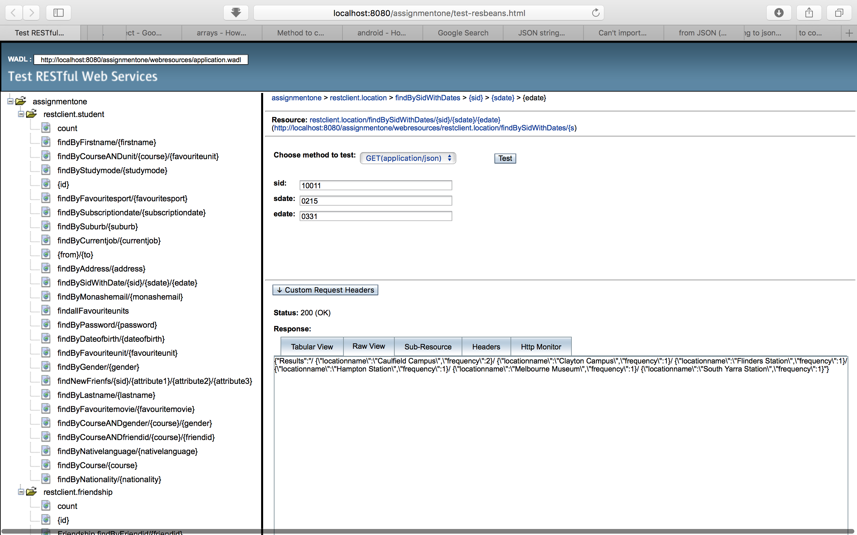

**Task 3c. List students with three attribute names**

**Task 3c - (1). Code in StudentFacadeREST class**

@GET

@Path("findStdWithSameCourseGenderJob/{sid}")

@Produces({"application/json"})

public JsonObject findStdWithSameCourseGenderJob(@PathParam("sid") int sid, @PathParam("course") String course, @PathParam("currentjob") String currentjob, @PathParam("gender") String gender)

{

TypedQuery<Object[]> q = em.createQuery("SELECT s.course, s.currentjob, s.gender FROM Student s WHERE s.sid = :sid", Object[].class);

q.setParameter("sid", sid);

List<Object[]> Lists = q.getResultList();

JsonObject jsonObjectq = Json.createObjectBuilder().build();

String a = "";

String b = "";

String c = "";

//String Overall = "";

String[] threeValues = new String[3];

for (Object[] element : Lists)

{

a = (String)element[0];

b = (String)element[1];

c = (String)element[2];

}

TypedQuery<Object[]> p = em.createQuery("select s.firstname, s.lastname from Student s where s.course = :course AND s.gender = :gender AND s.currentjob = :currentjob", Object[].class);

p.setParameter("course", a);

p.setParameter("currentjob", b);

p.setParameter("gender", c);

List<Object[]> Listsp = p.getResultList();

JsonObject jsonObjectp = Json.createObjectBuilder().build();

String jsonString;

String Overall = "";

for (Object[] element : Listsp)

{

jsonObjectp = Json.createObjectBuilder().add("firstname", (String)element[0]).add("lastname", (String)element[1]).build();

jsonString = jsonObjectp.toString();

Overall = Overall +" "+ jsonString + "/ ";

}

JsonObject finaljsonObject = Json.createObjectBuilder()

.add("Results",Overall)

.build();

return finaljsonObject;

}

**Task 3c - (2). Screen shot**

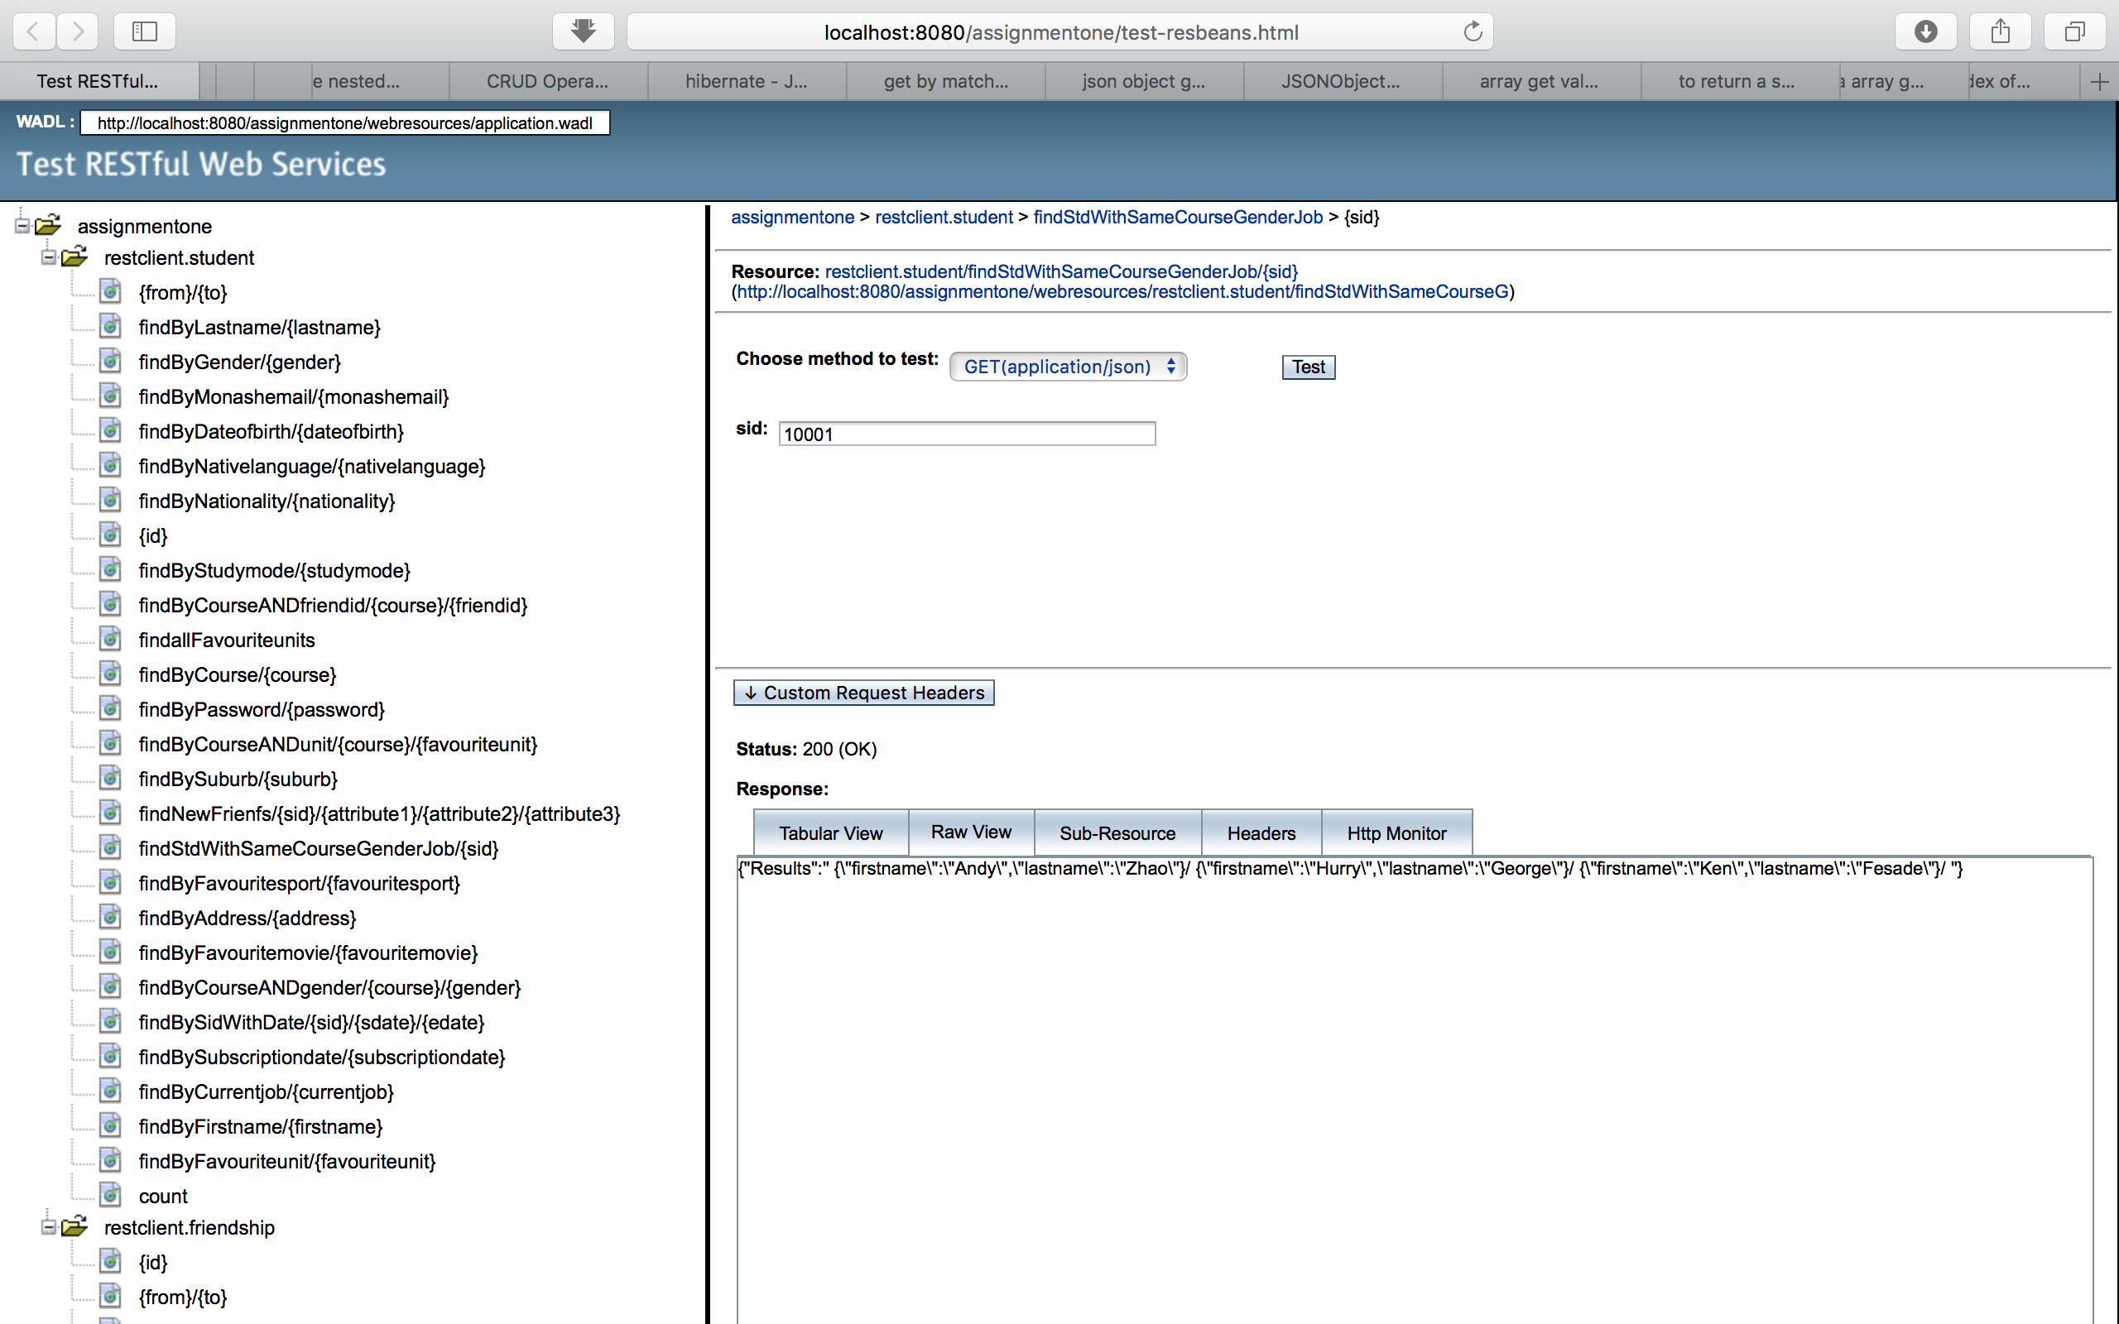

**Task 3d. List students matching any attribute names**

**Task 3d - (1). Code in StudentFacadeREST class**

@GET

@Path("findWithAnyAttributes/{sid}/{attributesSplitByComma}")

@Produces({"application/json"})

public JsonObject findWithAnyAttributes(@PathParam("sid") int sid,

@PathParam("course") String course,

@PathParam("currentjob") String currentjob,

@PathParam("gender") String gender,

@PathParam("address") String address,

@PathParam("dateofbirth") String dateofbirth,

@PathParam("studymode") String studymode,

@PathParam("suburb") String suburb,

@PathParam("nationality") String nationality,

@PathParam("nativelanguage") String nativelaguage,

@PathParam("favouritesport") String favouritesport,

@PathParam("favouritemovie") String favouritemovie,

@PathParam("favouriteunit") String favouriteunit,

@PathParam("password") String password,

@PathParam("monashemail") String monashemail,

@PathParam("subscriptiondate") int subscriptiondate,

@PathParam("firstname") String firstname,

@PathParam("lastname") String lastname,

@PathParam("attributesSplitByComma") String attributesSplitByComma

)

{

String[] attributes = attributesSplitByComma.split(",");

String qStringA = "";

for (String attribute : attributes)

{

String combination = "s." + attribute; // s.sid

qStringA = qStringA + combination + ", "; // s.sid,

}

String qStringb = qStringA.substring(0, qStringA.length() - 2);

String QueryA = "select " + qStringb + " FROM Student s WHERE s.sid = :sid";

TypedQuery<Object[]> q = em.createQuery(QueryA, Object[].class);

q.setParameter("sid", sid);

List<Object[]> Lists = q.getResultList();

JsonObject jsonObjectq = Json.createObjectBuilder().build();

String a = "";

String b = "";

String c = "";

;

String pStringA = "";

for (String attribute : attributes)

{

String levelA = "s." + attribute; //s.sid

String levelB = levelA + " = :"+ attribute; //s.sid = :sid

pStringA = pStringA + levelB + " AND "; //s.sid = :sid AND

}

String pQueryA = pStringA.substring(0, pStringA.length() - 4); // move last AND

String pQueryB = "select s.firstname, s.lastname from Student s where " + pQueryA;

TypedQuery<Object[]> p = em.createQuery(pQueryB, Object[].class);

int howLongLists = Lists.size();

int howLong = attributes.length;

for (Object[] element : Lists)

{

for (int j = 0; j < howLong; j++)

{

p.setParameter(attributes[j], (String)element[j]); // ("sid", sid)

}

}

List<Object[]> Listsp = p.getResultList();

JsonObject jsonObjectp = Json.createObjectBuilder().build();

String jsonString;

String Overall = "";

for (Object[] element : Listsp)

{

jsonObjectp = Json.createObjectBuilder().add("firstname", (String)element[0]).add("lastname", (String)element[1]).build();

jsonString = jsonObjectp.toString();

Overall = Overall +" "+ jsonString + "/ ";

}

JsonObject finaljsonObject = Json.createObjectBuilder()

.add("Results",Overall)

.build();

return finaljsonObject;

}

**Task 3d - (2). Screen shot.**

